CP5047 ICT Phase - 2

Assessment Task 3: PROJECT AUDIT(FINAL)

**Lecturer: Laura Antochi**



**www.romashka.ictatjcub.com**

|  |  |  |
| --- | --- | --- |
| **Team Members:** |  |  |
| Anastasia Verchak |  | ID:13446694 |
| Charanpreet Kaur |  | ID:13543377 |
| Harshitha Paderu |  | ID:13539782 |
| Rajendra Manandhar ID: 13530874 | | |

**TABLE OF CONTENTS**

ROLES AND CONTRIBUTIONS 3

PROJECT DESCRIPTION AND JUSTIFICATION 4

CLIENT ACCEPTANCE FORMS 5

FINAL RELEASE PROPOSED 9

FINAL RELEASED DELIVERED 10

CLIENT ACCEPTATION FOR THE FINAL RELEASE 12

DIFFERENCES BETWEEN ITERATIONS 14

ICT INFRASTRUCTURE 21

SERVER AND DOMAIN 21

CONFIGURATION MANAGEMENT 22

FRONT-END DEVELOPMENT TOOL 23

BACK-END DEVELOPMENT TOOL 23

FRONT-END DEVELOPMENT AND STYLING 25

THE DATABASE 27

THE HOSTING TOOL 29

THE RELEASE ENVIRONMENT 31

EXTERNAL FRAMEWORKS USED 32

PROJECT MANAGEMENT TOOLS 40

BURNDOWN CHART AND VELOCITY CHARTS 42

CLIENT TESTING 47

CLIENT USER MANUAL 64

CONCLUSION 68

# ROLES AND CONTRIBUTIONS

|  |  |  |
| --- | --- | --- |
| **Name** | **Project role(s)** | **Individual contributions** |
| Anastasia Verchak | Project manager, tester | * Client agreement * Prototypes * Communication with the client * White box testing * Project management tools * Documentation * Client testing acceptation form * Client acceptation form * Front end design * Moodle developing * Final presentation * Bug fixing |
| Charanpreet Kaur | Front-End Developer | * Configuration management   - Front-end development |
| Harshitha Paderu | Back-End Developer | * Burn down and velocity charts * Steps for new member to setup database and hosting environment * Development tools - phpmyadmin, hosting environment - WinSCP   - Back-end development  - External Framework Implementation and Maintenance  - Documentation Proof-reading and editing  - Bug fixing |
| Rajendra Manandhar | Front-  End Developer | * Front-end and Server Side Scripting * Bug fixing |

# PROJECT DESCRIPTION AND JUSTIFICATION

The initial goal of this project- Romashka- is to develop a responsive website with high efficiency, learnability, memorability and safety; for the staff, students/parents of the Russian language school - Romashka.

At this stage, Romashka is a fully functional web based application designed to fulfill the needs of the Russian Language School located at 6 Lawson Street, Southport, Queensland. This web application allows users (Students and Staff) to sign up into the student portal designed for intuitive teaching and learning process where they can see the subjects they have been enrolled, edit and update their profile, upload assignments and check the similarities between the students to avoid plagiarism with the help of online portal named Moodle.

Apart from this there is an admin portal where the admin of Romashka can log in with given credentials. Admin will have his own dashboard where he can see the details of students, teachers, receive messages from page visitors, add to and delete images from the gallery.

The project also incorporates a few external frameworks like FoxyCart and EventBrite for the successful working of some functionalities.

The following mentioned points are the most suitable justifications for this project:

1. Most of the Russian language school websites are NOT responsive.

2. They provide different and lesser information on their English version when compared to more information on their Russian version.

3. No website has a login portal for staff/students.

4. No website has a SSL certificate and so are not be trusted.

5. No website meets the standard layout that all business websites follow these days.

# CLIENT ACCEPTANCE FORMS

**Alpha Release**

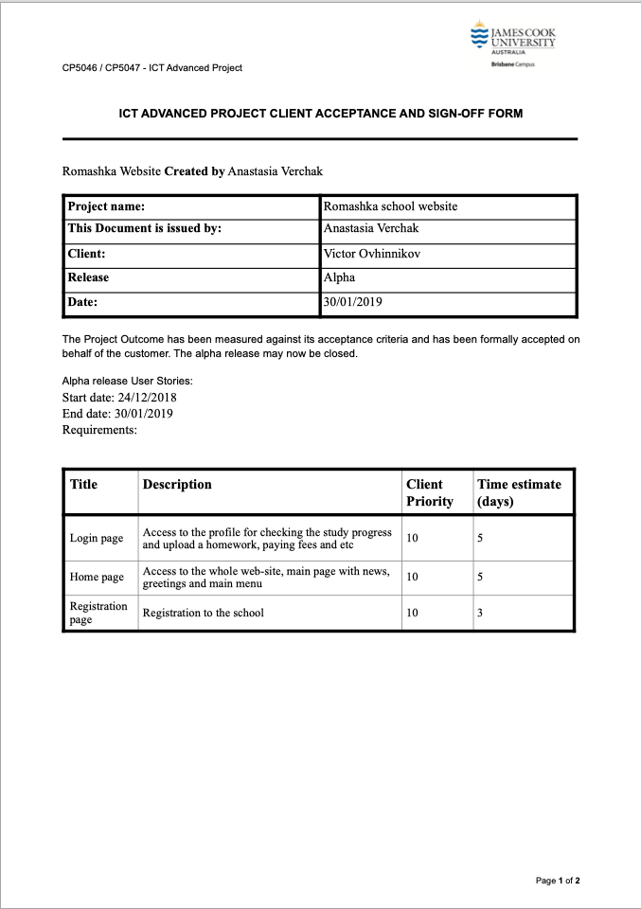

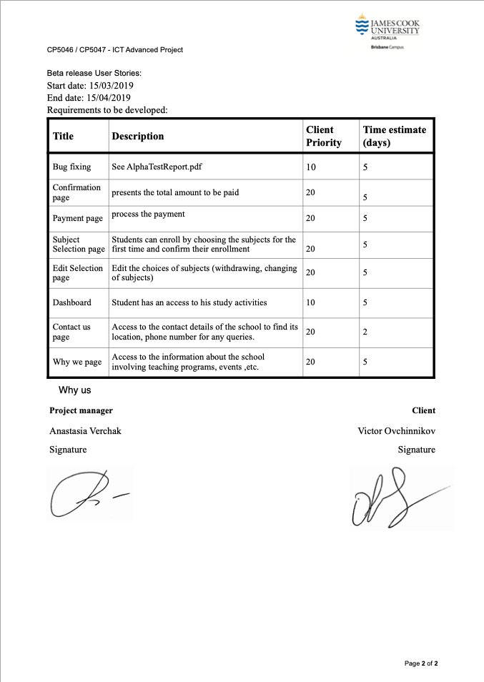

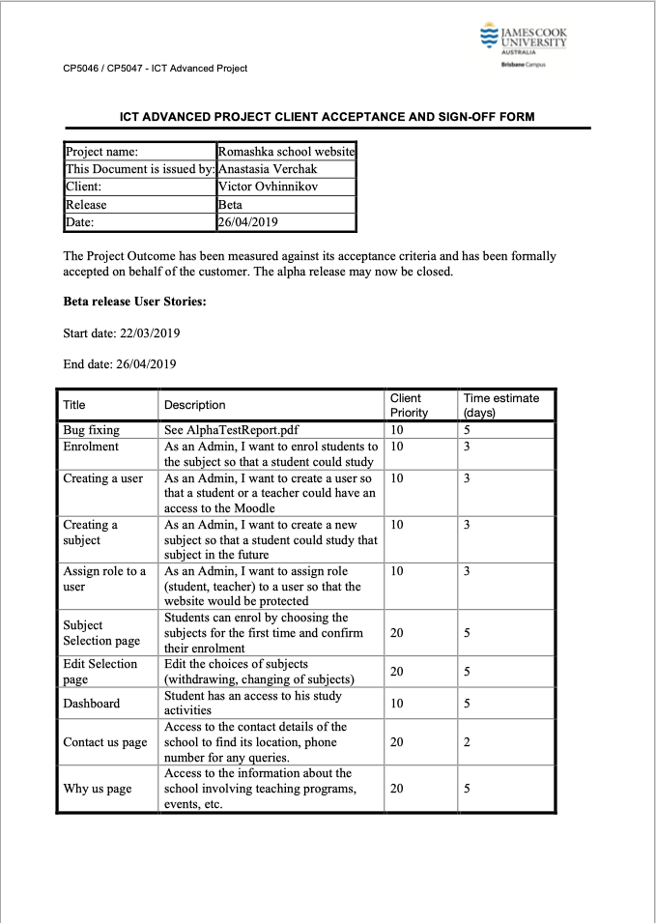**Beta Release**

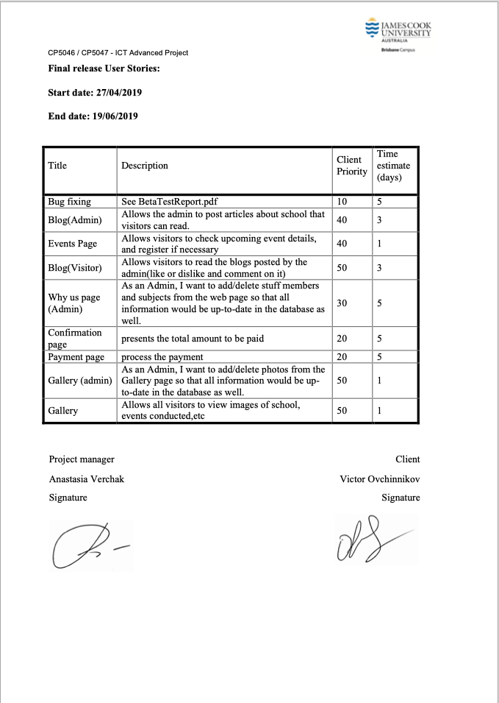

# FINAL RELEASE PROPOSED

|  |  |  |  |
| --- | --- | --- | --- |
| **Title** | **Description** | **Client Priority** | **Time estimate (days)** |
| Bug fixing | See BetaTestReport.pdf | 10 | 5 |
| News(Admin) | Allows the admin to post articles about school that visitors can read. | 40 | 3 |
| Events Page | Allows visitors to check upcoming event details, and register if necessary | 40 | 1 |
| News(Visitor) | Allows visitors to read the blogs posted by the admin(like or dislike and comment on it) | 50 | 3 |
| Why Us page (Admin) | As an Admin, I want to add/delete stuff members and subjects from the web page so that all information would be up-to-date in the database as well. | 30 | 5 |
| Confirmation page | Presents the total amount to be paid | 20 | 5 |
| Payment page | Process the payment | 20 | 5 |
| Gallery (admin) | As an Admin, I want to add/delete photos from the Gallery page so that all information would be up-to-date in the database as well. | 50 | 1 |
| Gallery | Allows all visitors to view images of school, events conducted, etc | 50 | 1 |

# FINAL RELEASED DELIVERED

**Start date: 27/04/2019  End date: 05/06/2019**

**Delivered User Stories:**

|  |  |  |  |
| --- | --- | --- | --- |
| Title | Description | Client Priority | Time estimate (days) |
| Events Page | Allows visitors to check upcoming event details, and register if necessary | 40 | 1 |
| News(Visitor) | Allows visitors to read the blogs posted by the admin(like or dislike and comment on it) | 40 | 3 |
| Confirmation page | presents the total amount to be paid | 20 | 5 |
| Payment page | process the payment | 20 | 5 |
| Gallery (admin) | As an Admin, I want to add/delete photos from the Gallery page so that all information would be up-to-date in the database as well. | 50 | 1 |
| Gallery (visitor) | Allows all visitors to view images of school, events conducted, etc. | 50 | 1 |
| Admin Dashboard | Allows the Admin to view Student and Teacher details, receive messages from visitors. | 30 | 5 |

**Undelivered User Stories:**

|  |  |  |  |
| --- | --- | --- | --- |
| Title | Description | Client Priority | Time estimate (days) |
| News(Admin) | Allows the admin to post articles about school that visitors can read. | 40 | 3 |
| Why us page (Admin) | As an Admin, I want to add/delete stuff members and subjects from the web page so that all information would be up-to-date in the database as well. | 30 | 5 |

**\*\* The above mentioned user stories could not be delivered by the developer as an additional feature, ‘Admin Dashboard’ was planned, and had to be delivered with a higher priority.**

# CLIENT ACCEPTATION FOR THE FINAL RELEASE

# 

# 

# DIFFERENCES BETWEEN ITERATIONS

**ALPHA**

Alpha stage was mainly about learning and team collaboration which were extremely important for the next two stages of the project development. After immense research and study, the team found that an implementing of Dashboard user story could have several issues, connected with the difficulties of developing and structure of the dashboard page. It was decided to:

* Move user story Dashboard to the Beta release
* Find external service which provides all appropriate sources for delivering customer’s requirements.

The User Stories developed during Alpha were:

* **Home Page**

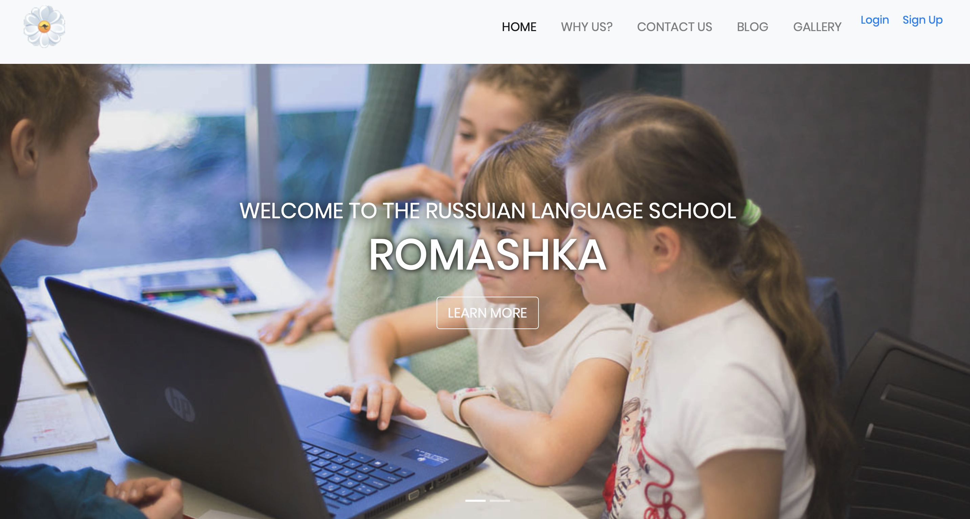

* **Registration Page and**

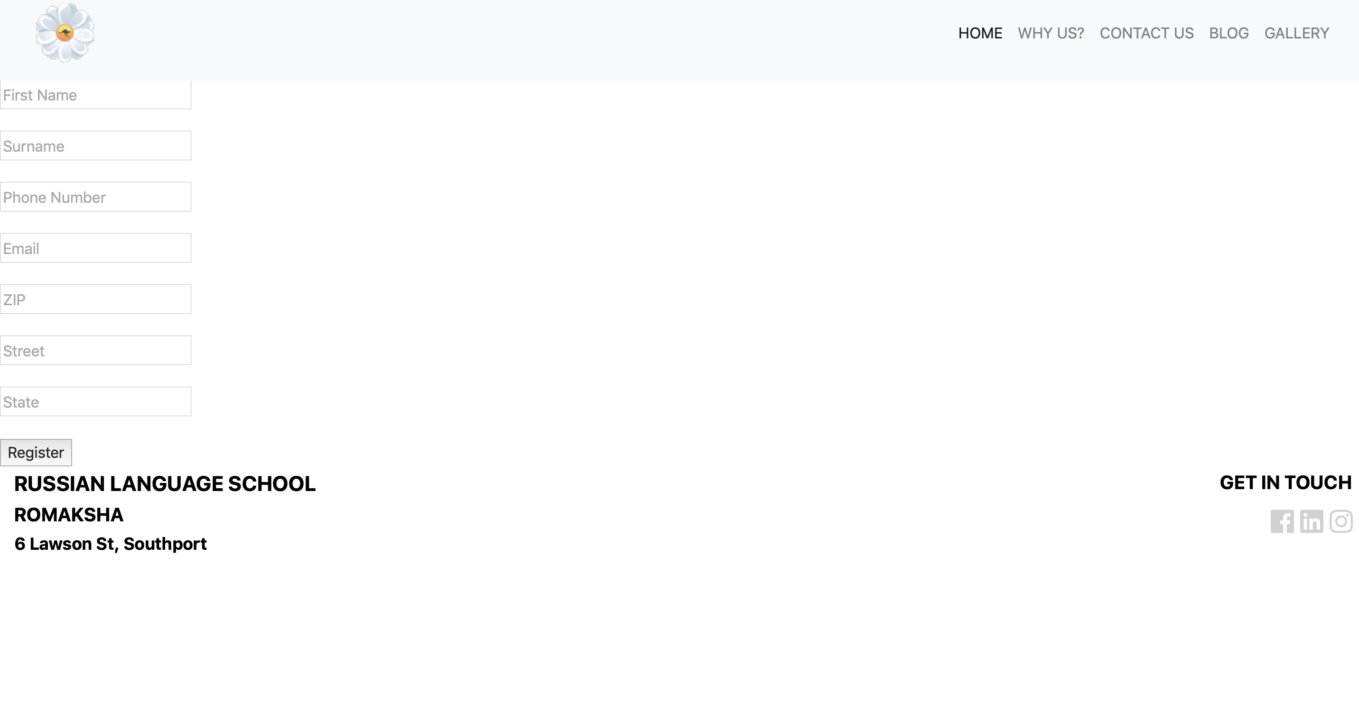

* **Login Page**

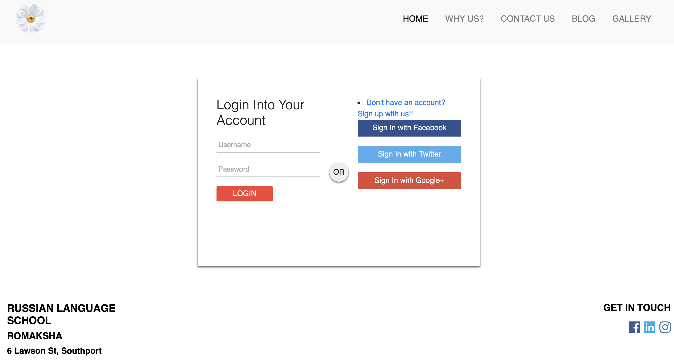

**The Database**

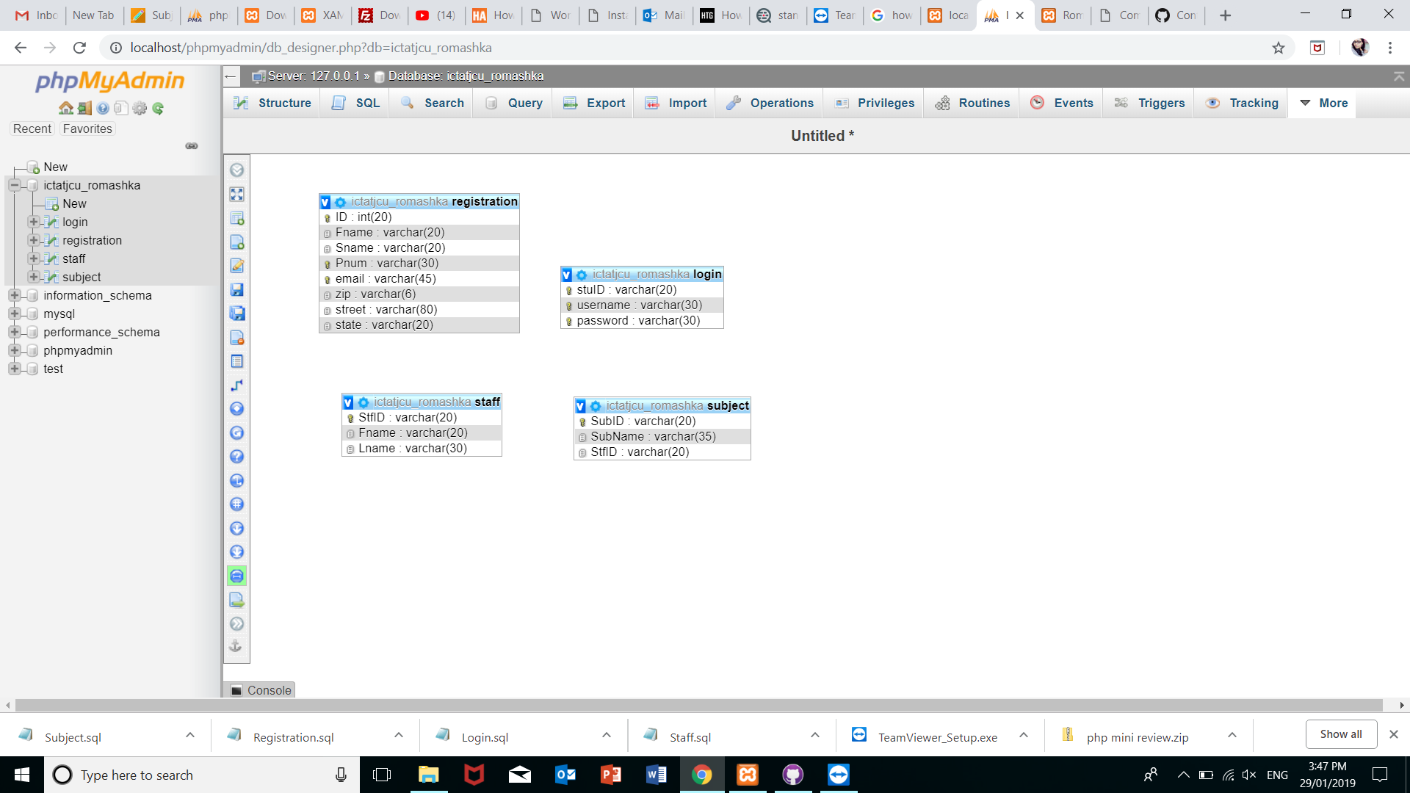

# BETA

As planned for the Beta release of Romashka, bugs that were encountered in alpha were fixed and major changes in the web application were made. The header, navigation bar, footer, login and registration page of the website had been changed as per the clients request. For beta release the front end design of the user profile dashboard (supported by Moodle), Contact Us Page and Why us page were completed.

**Moodle**



**Contact Us**



**Why Us?**





**The Database**



# FINAL

The subject selection page (cart) and payment page were postponed to the final release of the project Romashka because the client had given lesser priority to those pages. Also, for in the final release of the web application the admin panel was created which gave the flexibility to admin to view student and staff details, messages from page visitors, adding and deleting images from the gallery. External Frameworks like Foxycart and EventBrite are incorporated at this stage.

**Subject and Cart**

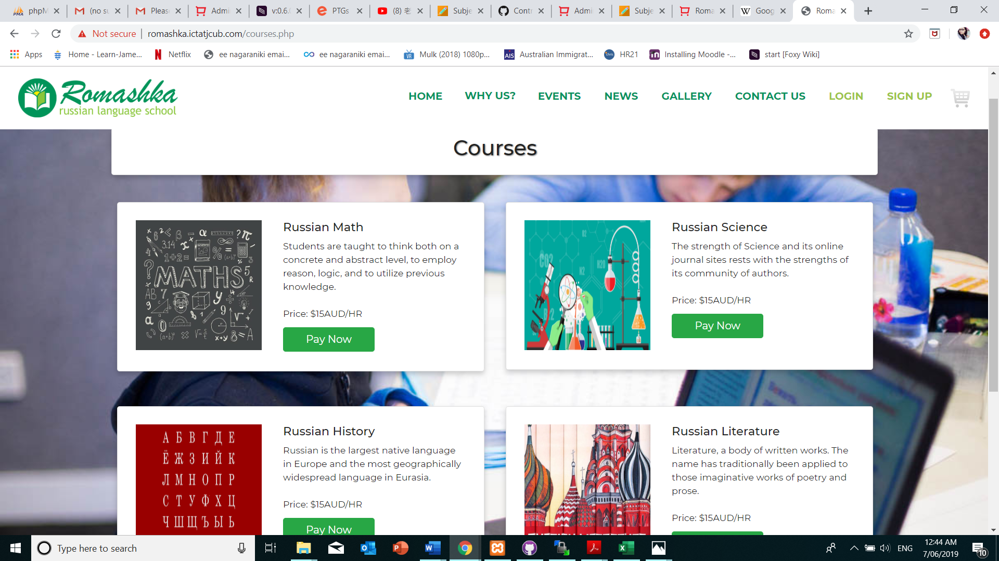

**Events**

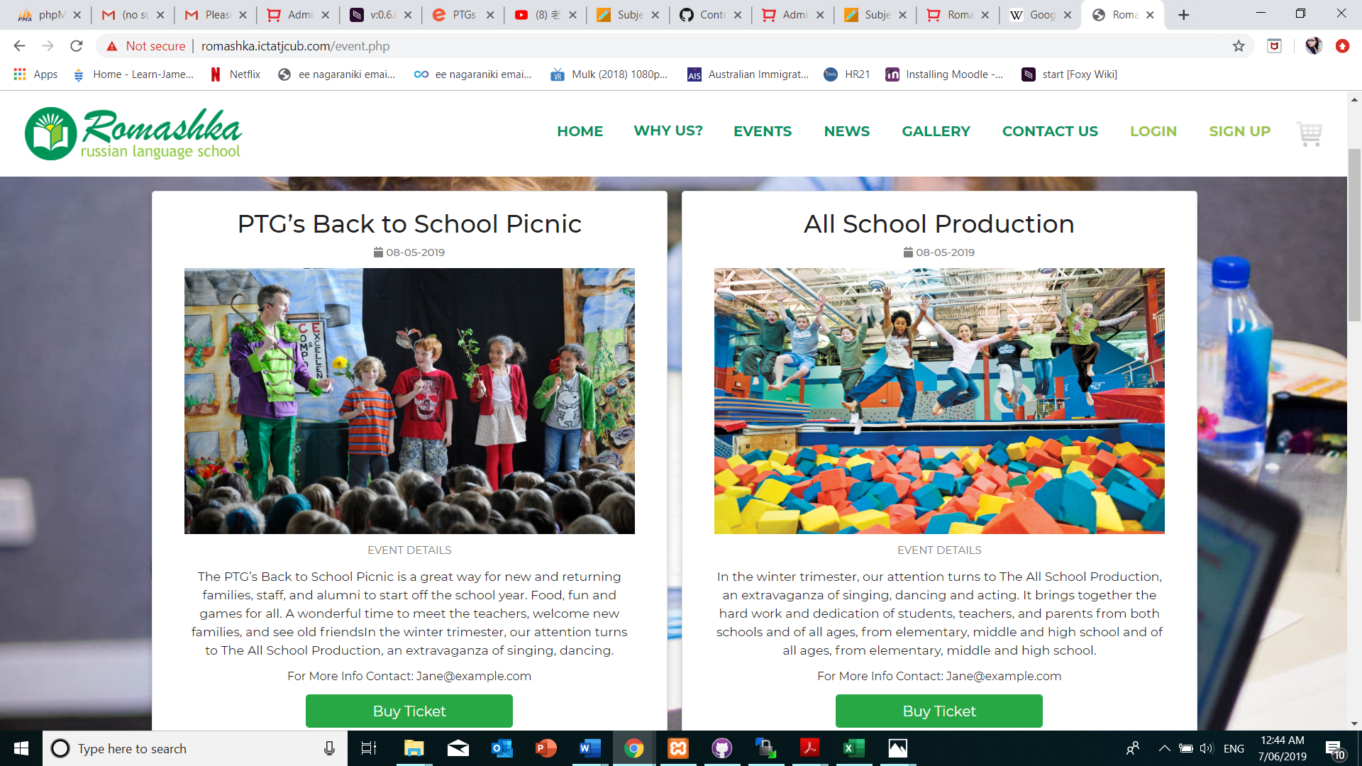

**News**

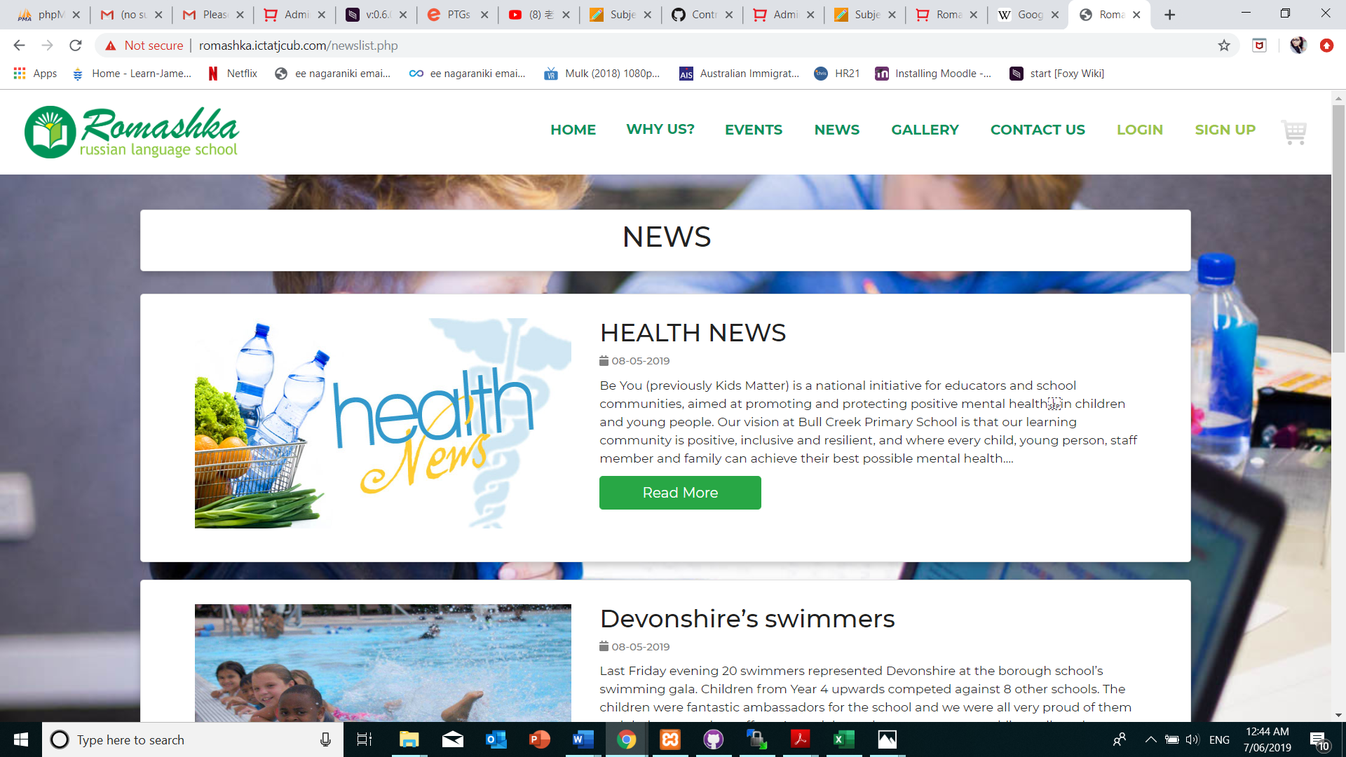

**Gallery**

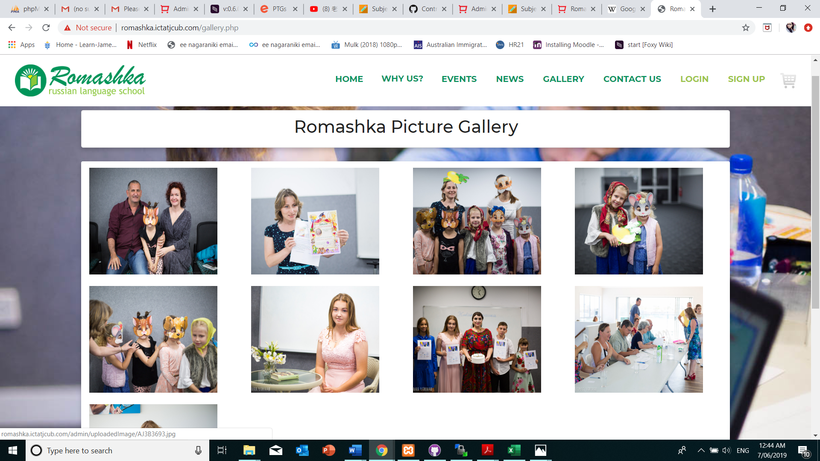

**Admin Dashboard**

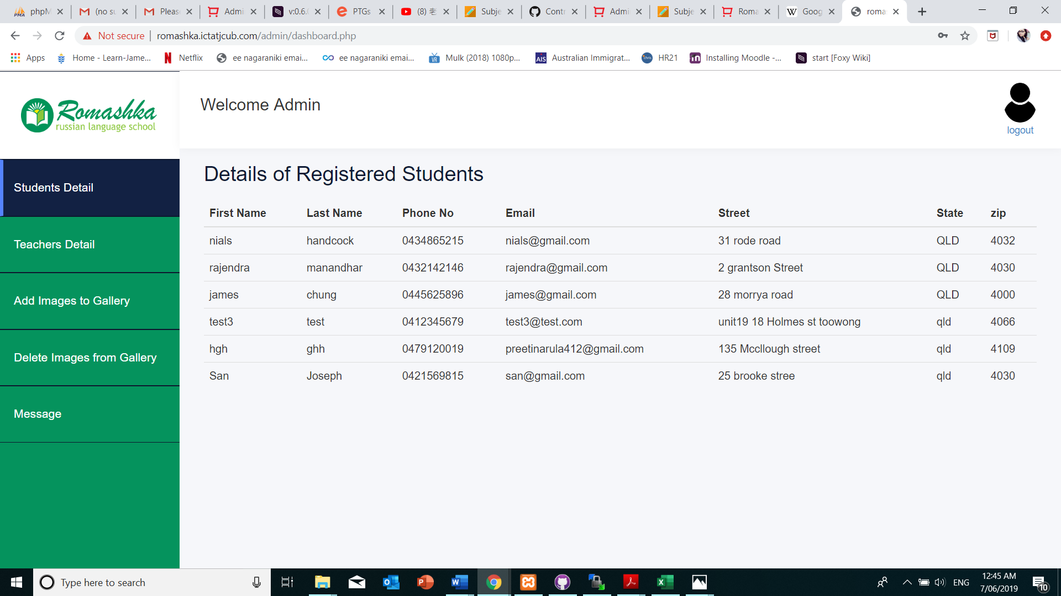

**The Database**

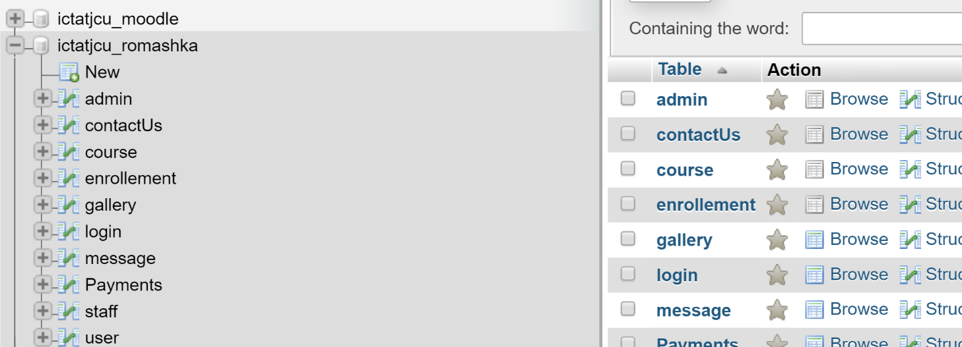

# ICT INFRASTRUCTURE

## SERVER AND DOMAIN

|  |  |
| --- | --- |
| **Subdomain:** | [romashka.ictatjcub.com](http://romashka.ictatjcub.com/) |
| **FTP host:** | [ftp.ictatjcub.com](http://ftp.ictatjcub.com/) |
| **FTP username:** | [romashka@ictatjcub.com](mailto:romashka@ictatjcub.com) |
| **FTP password:** | 123zxcA! |
| **Remote phpMyAdmin:** | [romashka.ictatjcub.com/phpmyadmin](http://romashka.ictatjcub.com/phpmyadmin) |
| **Database name:** | ictatjcu_romashka |
| **Database host:** | localhost |
| **Database user:** | ictatjcu_romashk |
| **Database password:** | 123zxc |
| **Moodle:** | <http://romashka.ictatjcub.com/moodle> |
| **Moodle database:** | ictatjcu_moodle |
| **Moodle database password:** | 123zxc |
| **Moodle database user:** | ictatjcu_moodle |
| **Moodle admin:** | Admin |
| **Moodle admin password** | 123zxc456! |
| **Romashka admin login** | admin@gmail.com |
| **Romashka admin password** | admin |

## CONFIGURATION MANAGEMENT

|  |
| --- |
| GitHub is an online version control service which stores our work in versioned fashion. We can revert to any version at any point in time. Multiple users can use a repository to store their work. |
| Link to the repository is as follow:  <https://github.com/harshithapaderu/Romashka> |
|  |
|  |
| FRONT-END DEVELOPMENT TOOL |
| Adobe Dreamweaver is a comprehensive tool developed by Adobe for web designers. We used Dreamweaver for designing our HTML and CSS pages. The integration with Git makes it flawless. It also supports JavaScript, PhP. |
| BACK-END DEVELOPMENT TOOL |
| **phpMyAdmin:**  PHP is a server-side scripting language that is embedded in HTML. It is integrated with number of popular databases like MySQL, Oracle, PostgreSQL, Informix, etc. |
|  |
| **Moodle Database** |
| A close up of a piece of paper  Description automatically generated FRONT-END DEVELOPMENT AND STYLING |
| **HTML and CSS:** |
| HTML stands for Hypertext Markup Language. It supports tags for various elements of a web page.  CSS is a styling language and works in tandem with HTML to create beautiful pages. |
|  |
|  |
|  |
| ** If a new team member is added in later phases, they have to install Dreamweaver. The previously developed pages can be found on the GitHub Repository. The new team member should understand our progress and be able to learn the programming needed. He/she should be able to understand the user stories and priorities. |

## THE DATABASE

phpMyAdmin is an open source toll that provides a Graphical User Interface to work with the MySQL database management system in case of this project. With phpMyAdmin, the admin can create, alter or drop databases and tables, create or remove users and user accounts, manage the privileges granted to a particular user, import and export data in SQL and other formats, etc.

The remote database for this project is located at ‘romashka.ictatjcub.com/phpmyadmin’.

The Username is ‘ictatjcu_romashk’ and Password is ‘123zxc’. Knowledge of these credentials are sufficient for existing members of the team and any plausible new members who may join the team.

This project contains two databases, a Database named ‘ictatjcu_romashka’ that is linked to the front end pages.

Another important database ‘ictatjcu_moodle’ was created. This database was used by the Moodle installer to create many tables used for the working of Moodle.

Steps for set-up of Database:

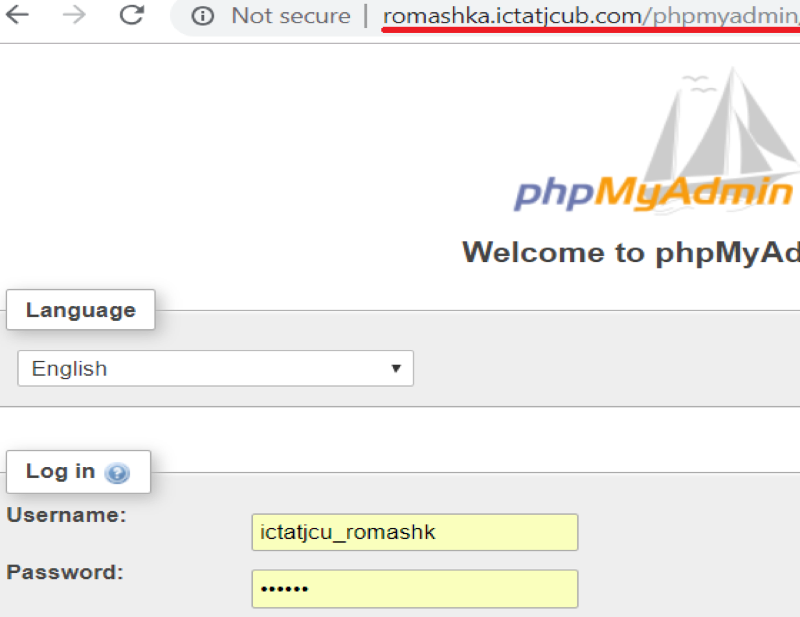**Step 1: Login**

**Step 2: Create Tables and Insert Data (Since Database is already created)**

Tables can be created using SQL or by clicking on the ‘+New’ button on the left hand side.

Similarly, data can be inserted using the Insert tab or by writing an SQL, or my Importing or Exporting from other existing databases, or Excel files.

The Table Columns and data can be seen or edited by selecting the respective table on the side bar. Also, the Primary keys, foreign keys, indexes and relationships can be updated under the ‘Designer’ tab.

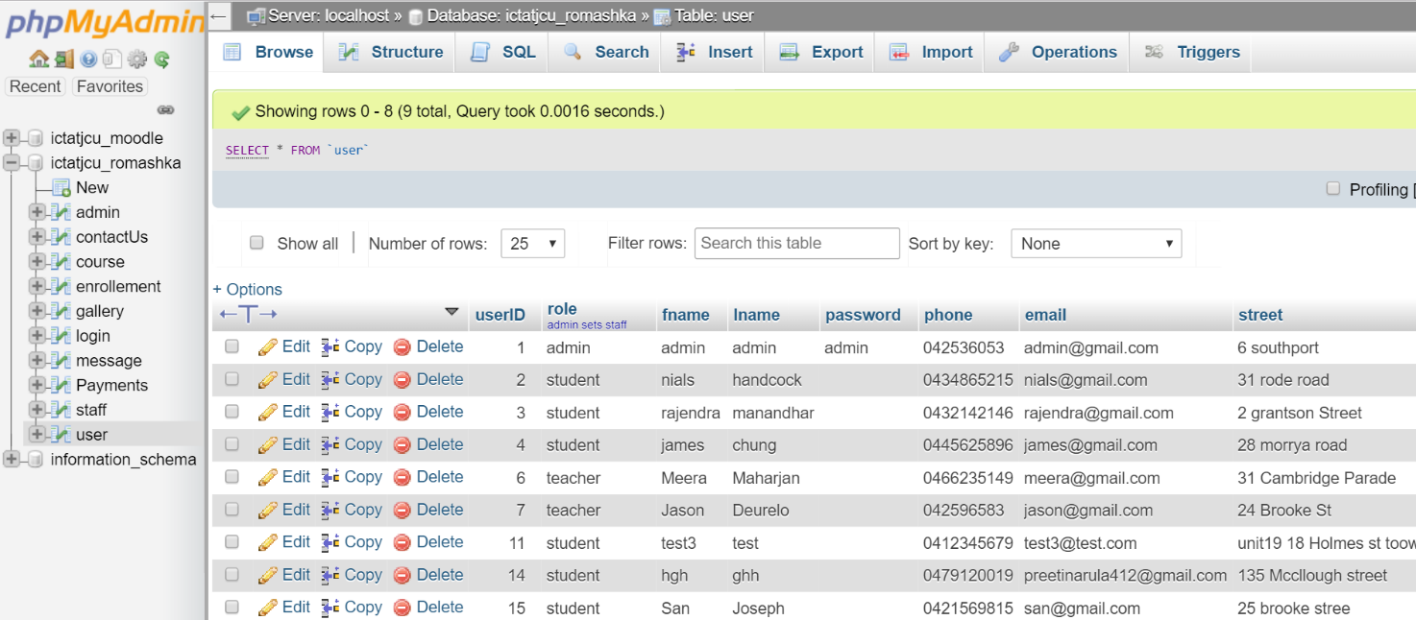

**Step 3: Creating a connection with the database.**

A config.php file contains the php code to enables connection with the database, is included in the <?php> .. ?> section of all the .php files created in the front end of the project.

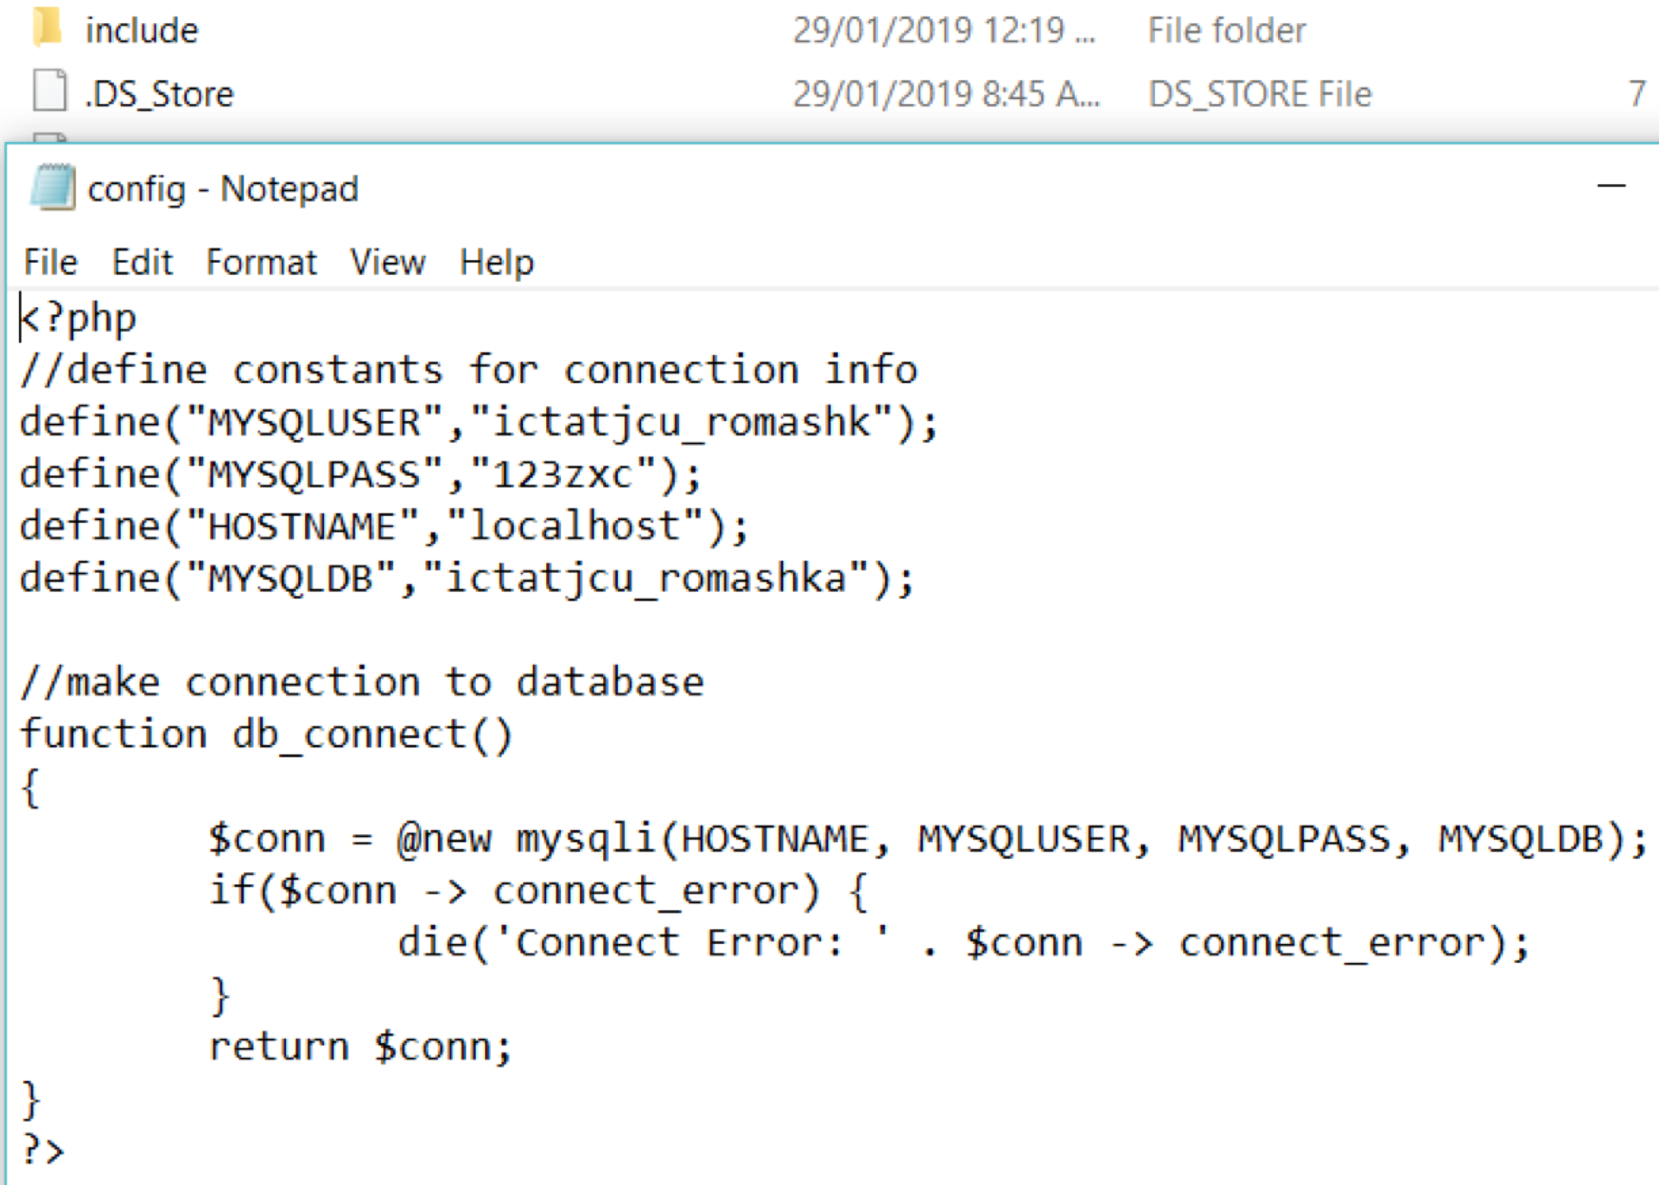Once the connection is established, suitable php code is inserted in the dynamic pages of the site to for validation and other functionality.

## THE HOSTING TOOL

The hosting tool chosen for this project is ‘WinSCP’. It is an open source FTP client, SFTP client, SCP client, etc. for Windows OS. Its main functionality is to establish a connection with the hosting space and perform File Transfer between a local and a remote computer, which then can we used to host onto a platform.

It provides a GUI and is integrated with Windows to provide basic operations with files and drag & drop facilities. For this project, its support with FTP protocols is utilised. It is faster compared to other hosting environments.

How to set-up WinSCP:

**Step 1:** On launching WinSCP after installation, it prompts us to login.

We use the hostname, host username and host password as the credentials to login, but before that, the File Protocol must be set to FTP.

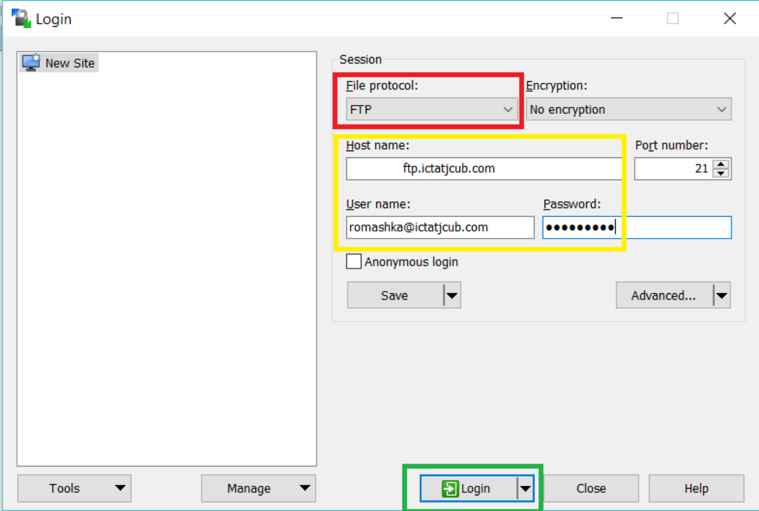

When the dialogue box (below) opens up, it means the connection has been established with the hosting space, and if successful the session has started.

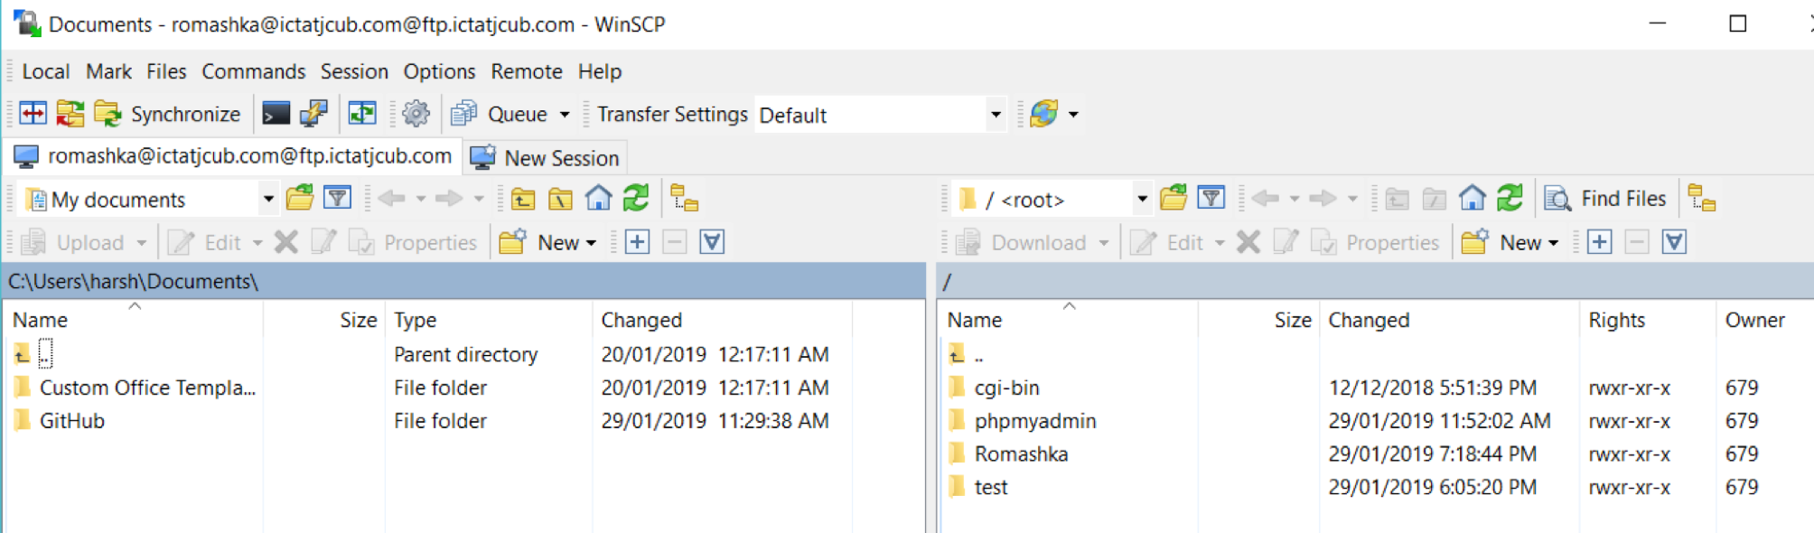On the left-hand side are the files of the local computer and on the right-hand side are the files on the remote computer.

**Step 2: Perform File Transfer**

The files of the website are all place in a folder name ‘Romashka’. We can simply drag these files from the left hand side of the screen (local PC) and drop them into the right-hand side, the remote computer.

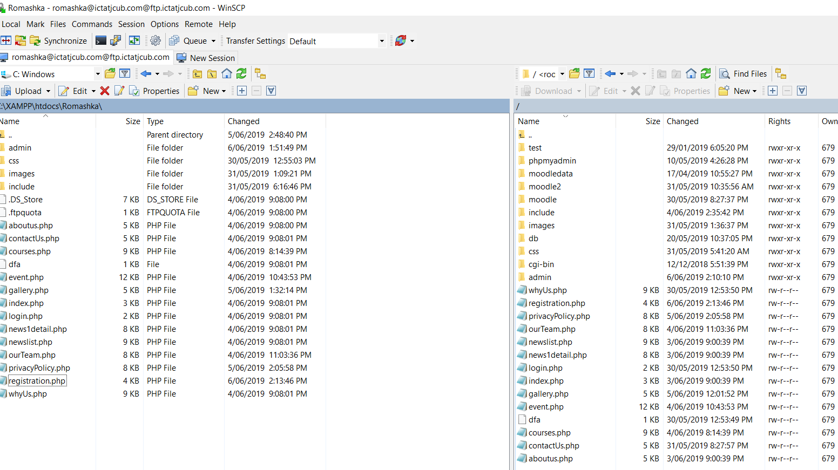**Step 3: Ready for the Client to test**

The files or the website is now on the remote server and can be tested by the client. The URL for the client to go to the website is: http://romashka.ictatjcub.com, because the hosting environment is configured to look for index files from the folder by default and run them automatically.

## THE RELEASE ENVIRONMENT

The Release Environment used to host this project is the Google Chrome Browser developed by Google Inc.. Chrome serves as a platform to serve or host web applications and web pages.

Steps to host are as follows-

**Step 1: Open the browser and enter URL**

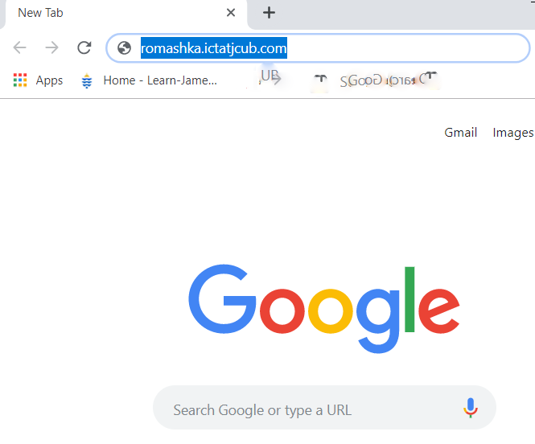

**Step 2: Once the Landing page or the Homepage is displayed, use the links to navigate through the website.** 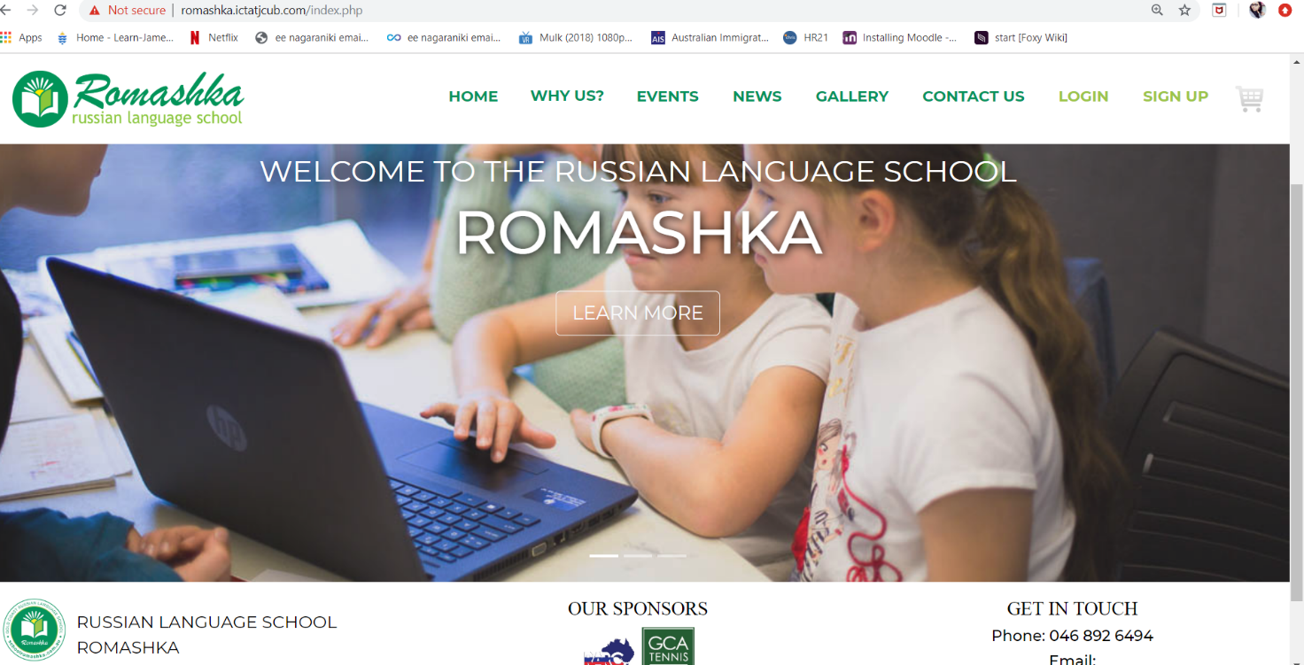

# EXTERNAL FRAMEWORKS USED

**Moodle**

Moodle is a Learning Management System, designed for instructors, administrators and students to create their own personalised learning environments.

The advantage of Moodle is that it is an open source software available under the GNU Public License and can be simply installed onto the web server. It is developed in Linux using Apache, MySQL and PHP.

The hardware requirements for Moodle are:

Disk Space- 200MB for the code and minimum of 5GB to store content.

Processor- 2GHz dual core is recommended.

Memory- 1GB or more is recommended.

After thorough research, it was decided that Moodle is the best suited LMS for this project because of a number of benefits it has.

In Moodle, a Dashboard is available for students to check daily notifications when course contents are added, the information about enrolled subjects and the instructors of the respective courses.

This feature is the most desired feature for the project ‘Romashka’- as it distinguishes it from other Language school websites.

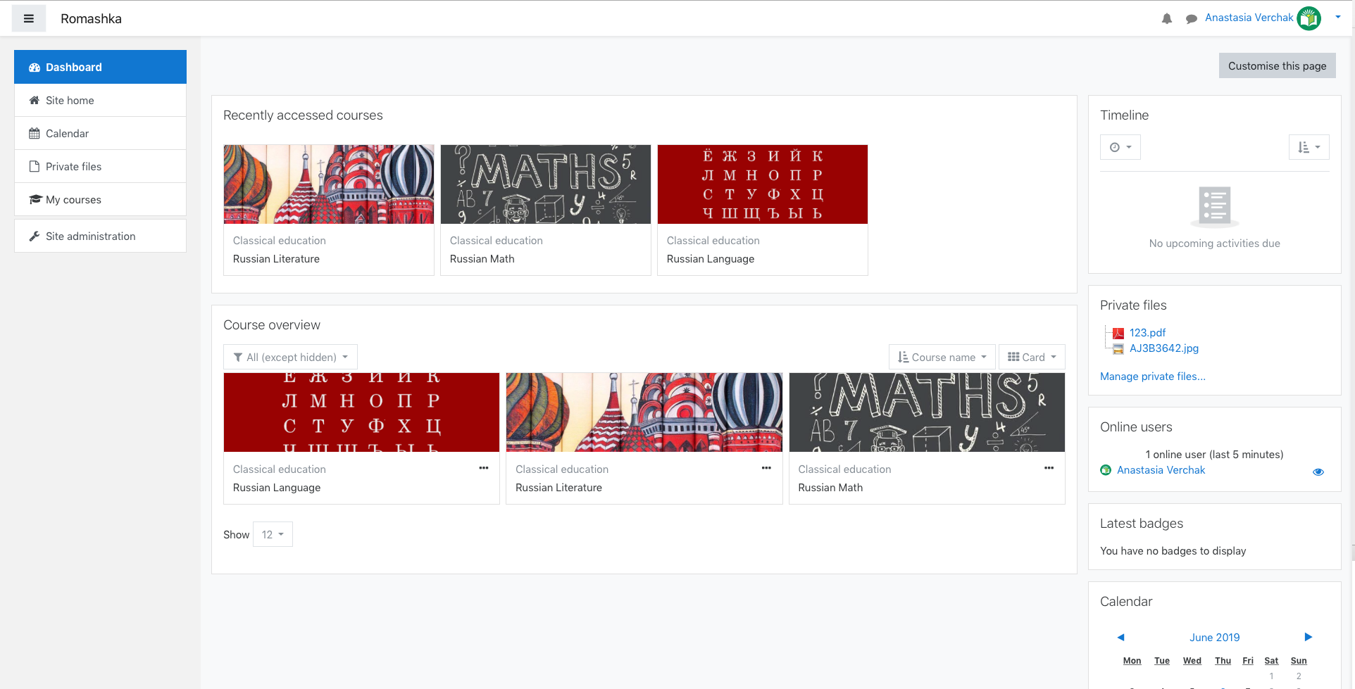

The following figure shows Moodle’s Student View:



An interesting feature provided by Moodle is that students can search within their courses the discussions had with peers or teachers. Any virtual classroom sessions conducted are recorded and the chat histories are available for students to review them whenever the need be.

Moodle allows random and automatic allocation of students into groups. The groups can be edited only by the teachers.

Moodle provides an extra feature called the Moodle Community Hub where students or instructors can access a location to share ideas or resources with peers, they can join in with communities hosted by other websites and yet is secure and can be set to be controlled only by the admin.

The assignments are submitted in a similar fashion but in Moodle, the assignments are saved as drafts if the student missed to click the submit button and closes the window.

**EventBrite**

Eventbrite is a global platform for live experiences that allows anyone to create, share, find and attend events. EventBrite enables Built in payment processing and analytics for event creators.

Since, Romashka hosts many evets from time to time and integrating a ticket buying system into the website was quite complicated at the final stage. EventBrite is used by the admin to create events and publish them. Students or page visitors can simply register for the event by clicking the ‘Buy Ticket’ button on the Events Page of the website.

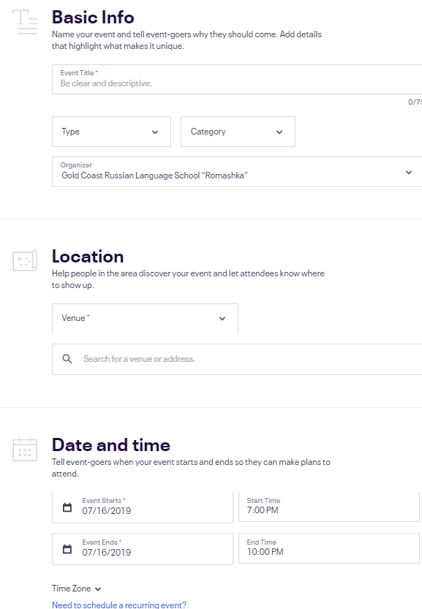 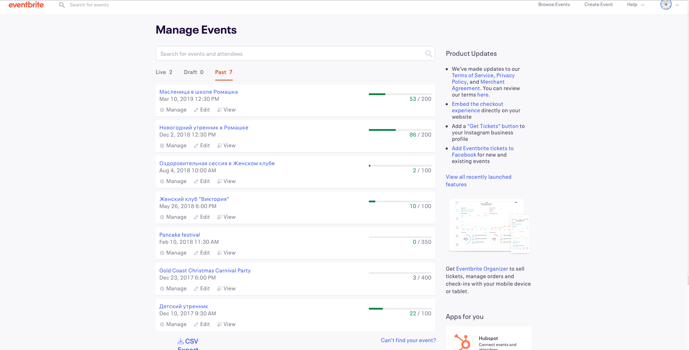

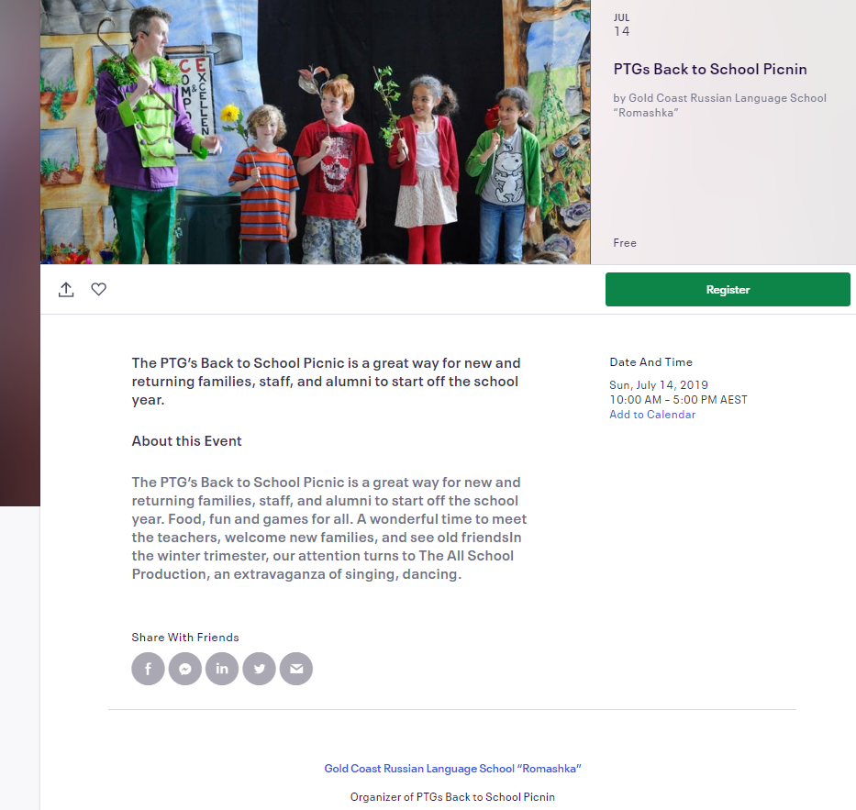

**FoxyCart**

To learn the algorithm for accepting payments through the site using a payment gateway, we turn to FoxyCart service. The payment gateway allows you to accept payments by Visa, MasterCard, amazon pay, also with the help of PayPal. At it's most basic, FoxyCart is as easy as adding a link or a form to the existing site. Beautiful, responsive templates get up and running quickly, and it's easy to add coupons, taxes, shipping, and more.

FoxyCart is built by developers, for developers, to integrate into own sites, systems, frameworks, and CMSs. Get a flexible cart and hosted payment page, exactly where and how client want it.

FoxyCart supports both one-off and recurring billing for physical products, downloadable, donations, intangible and virtual, goods, and fully customizable products. Mix and match as needed and without limitations.

FoxyCart accepts all kinds of payment- Credit and debit cards, PayPaL, Amazon Payments, bitcoin, and many, many more for both domestic and international customers. (FoxyCart, n.d.)

In order to accept credit card payments online, a merchant typically needs all of the following:

* **A website.**
* **An ecommerce platform.** FoxyCart is an obvious example. Nearly all ecommerce systems have an integrated CMS. FoxyCart is different in that regard.
* **The payment gateway.** The ecommerce system's checkout page receives payment information (ie. the credit card number) from the customer, and sends that info to the payment gateway in order to authorize transactions. The gateway responds indicating success or failure (and the corresponding error code). Most gateways have a monthly fee as well as a small (~$0.05 USD) per transaction fee. Gateways typically send transactions to your merchant account to capture once a day as a “batch”. Common gateways are Authorize.net, Stripe, Braintree, and Chase Paymentech.
* **The merchant account.** The merchant account actually collects (“captures”) the money from the transactions that the gateway processes. This is where you get docked the 2-4% transaction fee for processing credit cards, as well as fees for the transaction and occasionally other fees. Once a day your merchant account deposits all its money into your bank account in a “batch”. Depending on your merchant account provider, your fees may be taken out when payment is batched (daily), or the fees may be taken out all at once, once a month. (Some gateways are provided by the merchant account provider, like SecureNet, Stripe, Braintree, PayPal Payments Pro, etc.)
* **The bank account.**
* **Accounting, inventory, marketing, and etc.** There are countless systems to help client manage business. Most don't actually involve themselves in the actual transaction process, so they don't matter to this discussion. (FoxyCart, Gateways, Merchant Accounts, Bank Accounts, Oh My!, n.d.)

To start work, registration in the FoxyCart system is required. On the official website, the customer has to set-up their store, the payment gateway, cart, checkout functions, email and web receipts. As FoxyCart provides various templates for all these components, setting up a store is made very easy.

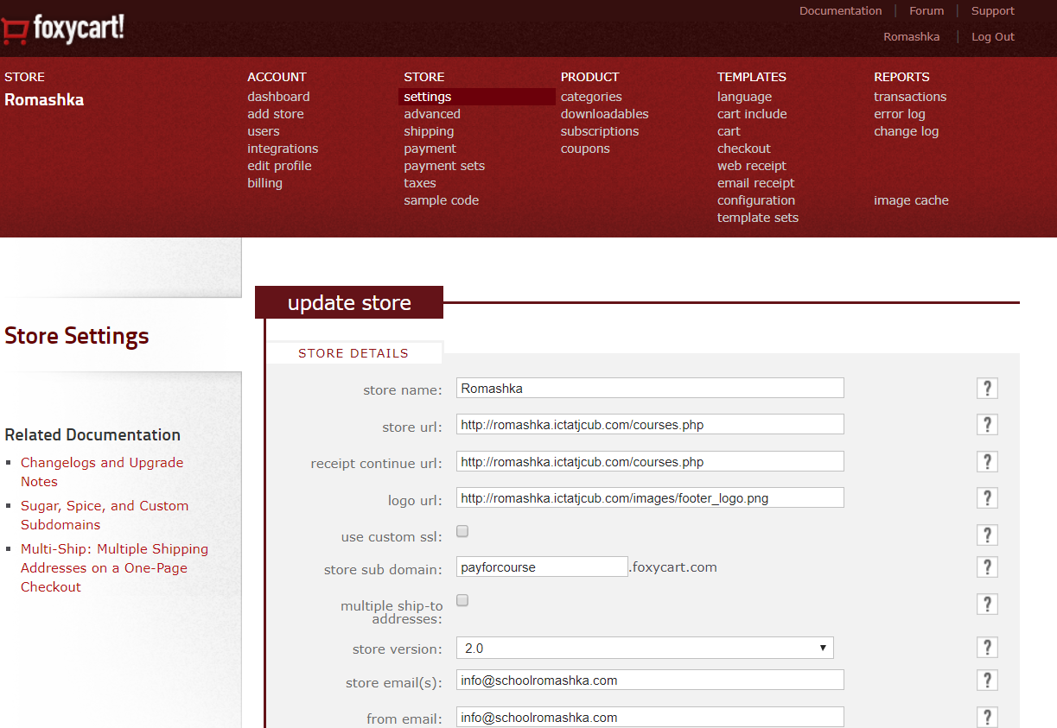

The Next step is to add code, which were provided by FoxyCart to the appropriate webpage right before the closing </body> tag.

<!-- FOXYCART -->

<script data-cfasync="false" src="https://cdn.foxycart.com/romashka/loader.js" async defer></script>

<!-- /FOXYCART -->

Then create cart add links and forms by using the code bellow:

<!-- link example -->

<a href="https://romashka.foxycart.com/cart?name=Cool%20Example&price=10&color=red&code=sku123">Trimester</a>

<!-- form example -->

<form action="https://romashka.foxycart.com/cart" method="post" accept-charset="utf-8">

<input type="hidden" name="name" value="Trimester payment" />

<input type="hidden" name="price" value="720" />

<input type="hidden" name="code" value="sku123" />

<label class="label_left">Size</label>

<select name="size">

<option value="small">Small</option>

<option value="medium">Medium</option>

<option value="large">Large</option>

</select>

<input type="submit" value="Trimester payment" class="submit" />

</form>

When this part is done, more settings are required inside of the account. The system allows to use two type of servers for our purposes: Live servers and Test servers.

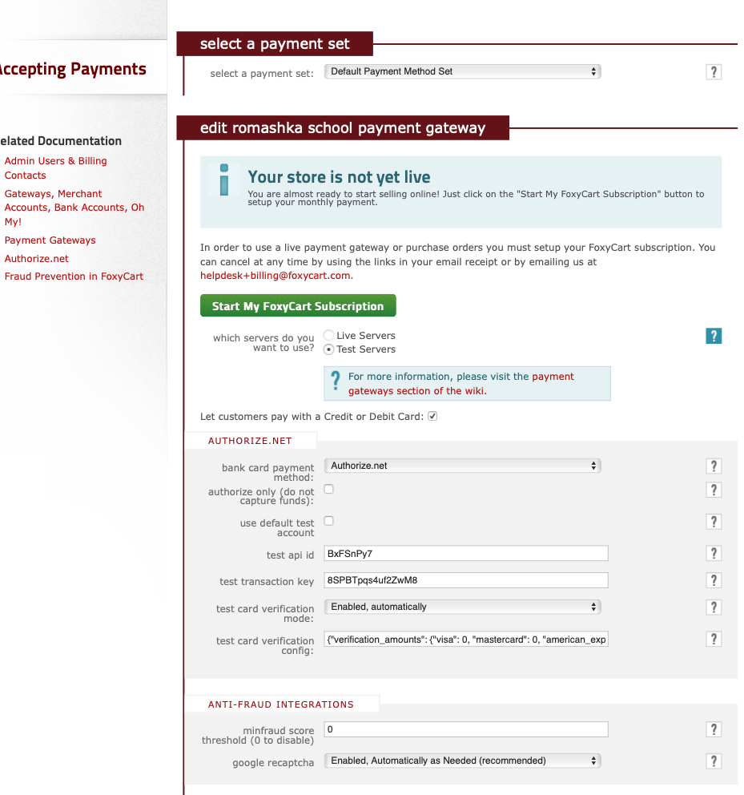Live servers need: Customer has to have a full version of FoxyCart subscription and Agreement with CommonWealth Bank.

Some other important and bonus features of FoxyCart enables the admin to check successful transactions and the error log (unsuccessful transactions) on the admin dashboard.

The transactions can be downloaded in a .csv format and imported into the database of this project as a backup.

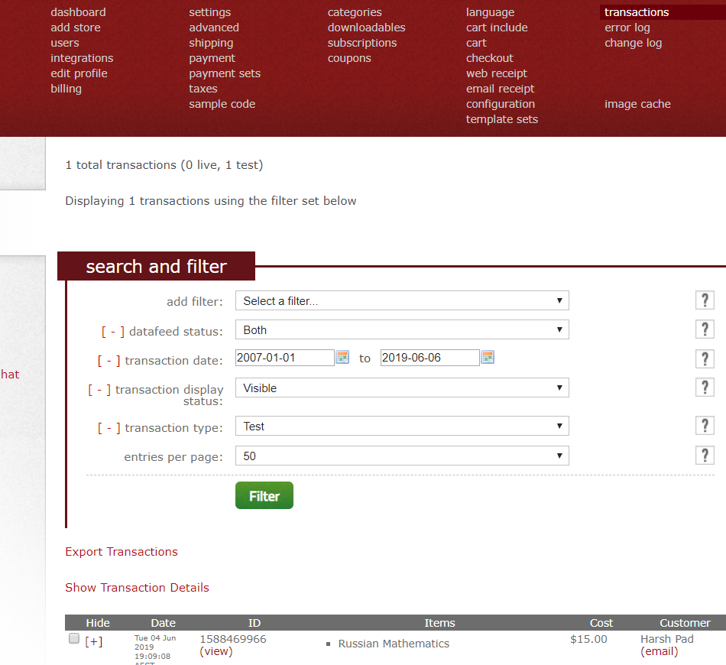 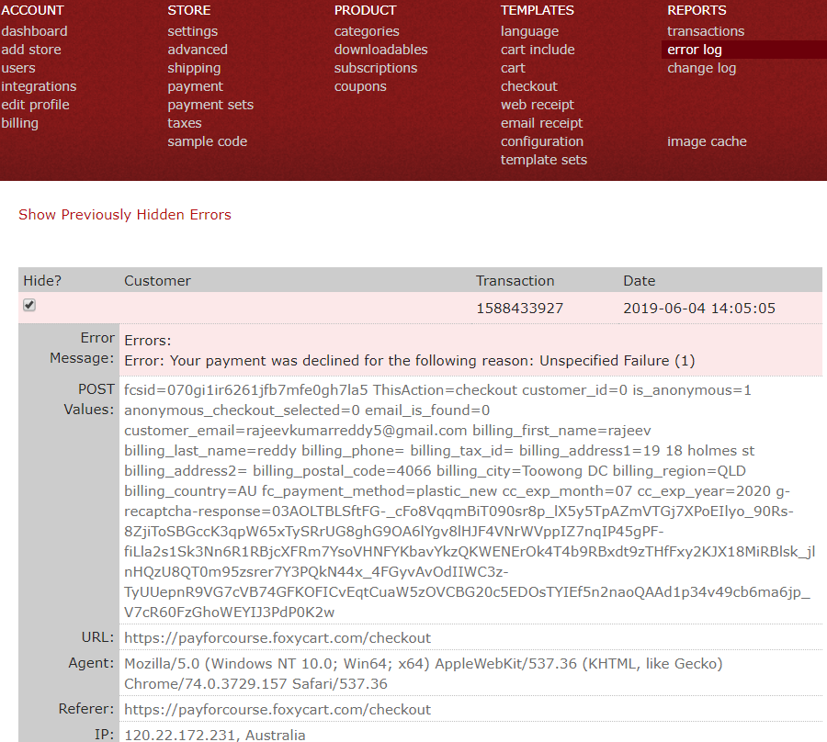

Below are some illustrations of how the cart and payment gateway look like on the website:

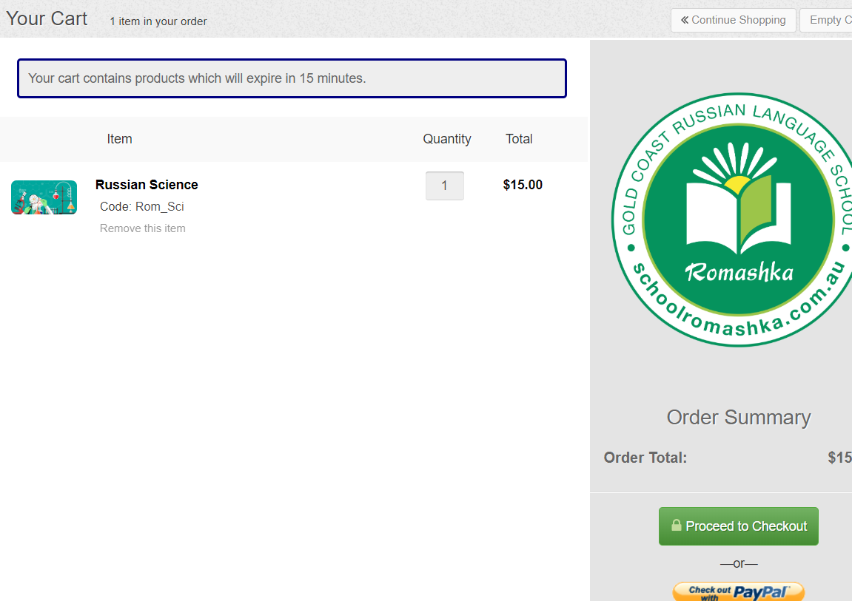

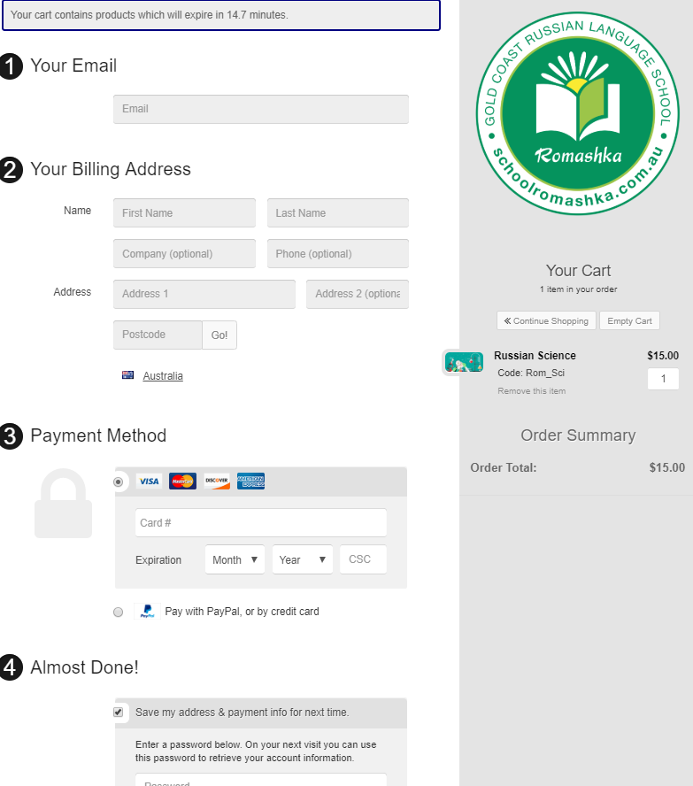

# PROJECT MANAGEMENT TOOLS

Project management - it is the process of achieving a particular goal within a given framework (time, budget, etc.). At the same time, the concept of PM also includes a set of tools, techniques, skills and techniques that are used to achieve the goal and can vary depending on the changing conditions in which the work is carried out (the appearance of both risks and opportunities).

**Trello**

Trello is a web-based collaboration service that can help organise and manage projects using cards.  
The main advantage of Trello can be called viewing several simultaneously running projects and their status at the moment. To work with a group of developers or other artists working on projects with deadlines or goals, this system can give an idea of the progress of projects.

In Trello, the emphasis is on packs of cards. Each pack shows the status of any project. For 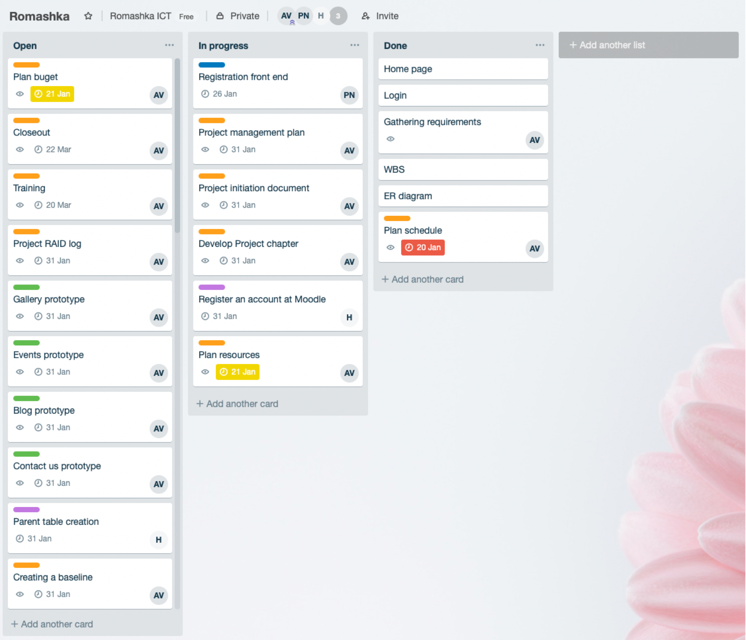example, if select a team to work, then in the first column there will be cards with a things which has to be done, in the second - tasks in progress, in the third there may be ready tasks, in the fourth - meetings and other general things.  
Cards have many features. They are intended for discussions, polls, download files and data. It is possible to set deadlines, assign text and color labels. To assign an executer to any task, it is necessary to select it in the card from the list of work team or simply drag the executer’s avatar to the task on the right.  
It is important to note that all team members see changes in real time and can monitor the status of individual executers — online or offline.  
Trello is available both in the web interface and as an application for the iPhone. On the iPad, the service works similarly to a desktop implementation.

**Slack**

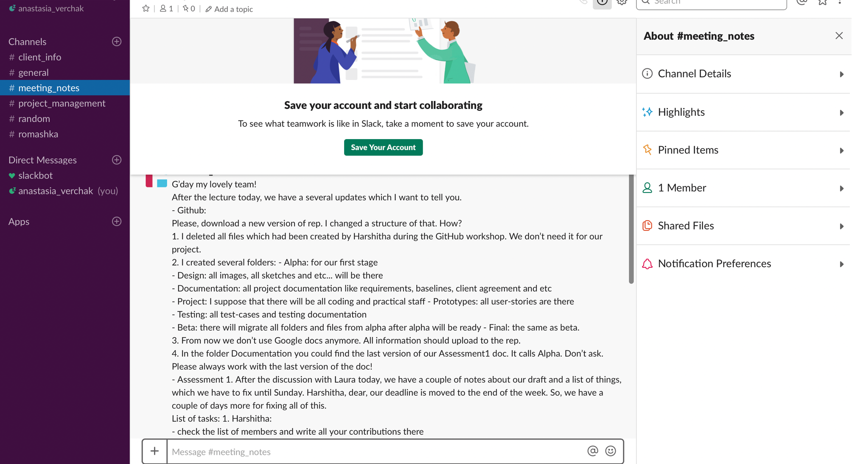Slack is an online service for correspondence within the team and a large company, but in fact it is a replacement for Skype for such conversations. This service has the ability to closely integrate active dialogs with other applications. This principle allows you to monitor the progress of work on various projects using one interface and remove unnecessary information.

**GanttPro**

GanttPro - Gantt chart that allows project manager to plan and manage projects online, visualise processes, create tasks and assign them to participants, set deadlines and percentage of individual tasks and the project as a whole, add milestones and share the created Gantt schedule with the team and with clients with the right to view or edit.

# BURNDOWN CHART AND VELOCITY CHARTS

**THE BURNDOWN CHART:**

The Burndown chart was used to track the progress of the project that now stands complete. This chart represents the progress for the Final Release of this project and the analysis will also help in understand the progress of the overall project, over all three iterations Alpha, Beta and Final.

**ALPHA**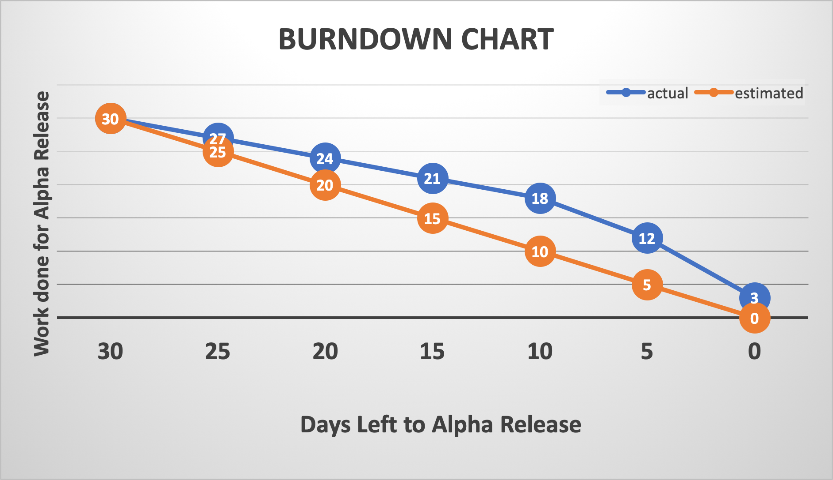

**TEAM VELOCITY FOR ALPHA:** **60%**

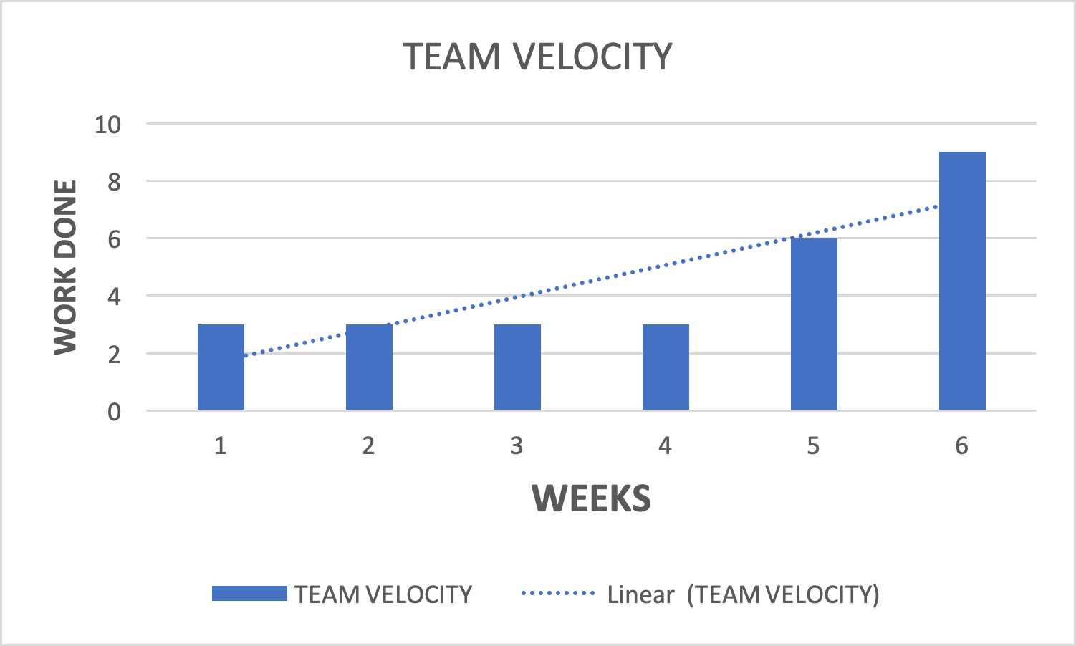

**BETA**

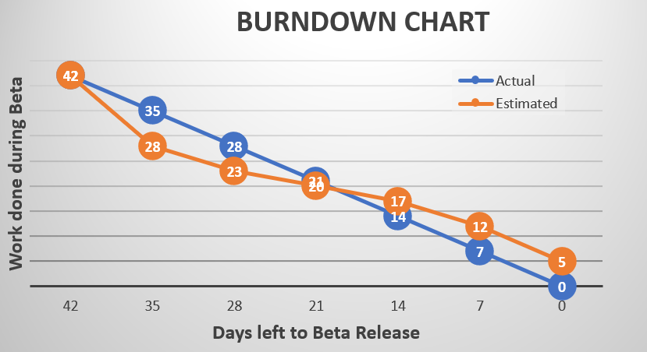

**TEAM VELOCITY FOR BETA:** **88.095%**

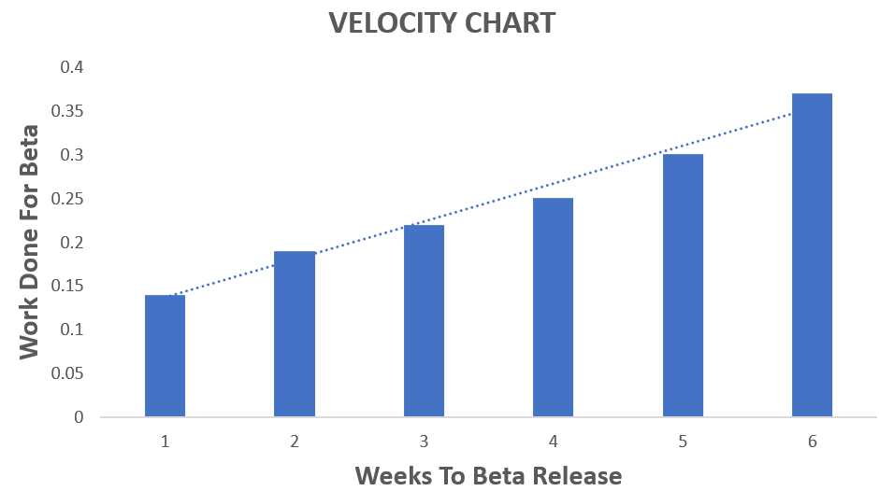

**FINAL BURNDOWN CHART**

In this chart, on the X-Axis are the Number of Days that were allocated to all the User Stories that were planned for the Final Release, which was 42. And on the Y-Axis are typically the User Stories (or the work that had to be done) to get to the completion of the project.

The User Stories that were to be completed (includes fixing the bugs from Beta) and the days allocated in Beta are shown in the table below:

|  |  |  |
| --- | --- | --- |
| **Final User Stories** | **Days Allocated** | **Status** |
| Bug Fixing from Beta | 5 | **COMPLETED** |
| Events Page | 1 | **COMPLETED** |
| News(Visitor) | 3 | **COMPLETED** |
| Confirmation page | 5 | **COMPLETED** |
| Payment page | 5 | **COMPLETED** |
| Gallery (admin) | 1 | **COMPLETED** |
| Gallery (visitor) | 1 | **COMPLETED** |
| Admin Dashboard | 5 | **COMPLETED** |
| News(Admin) | 3 | NOT COMPLETED |  |
| Why us page (Admin) | 5 | NOT COMPLETED |  |

All the User Stories that were to completed during the Final Iteration could not be successfully developed. A new user story ‘Admin Dashboard’ was added and had to be completed with a higher priority. As a result of this, the completion of the Final release took longer than expected.

This lag is represented by the green line (Actual) in the Burndown Chart.

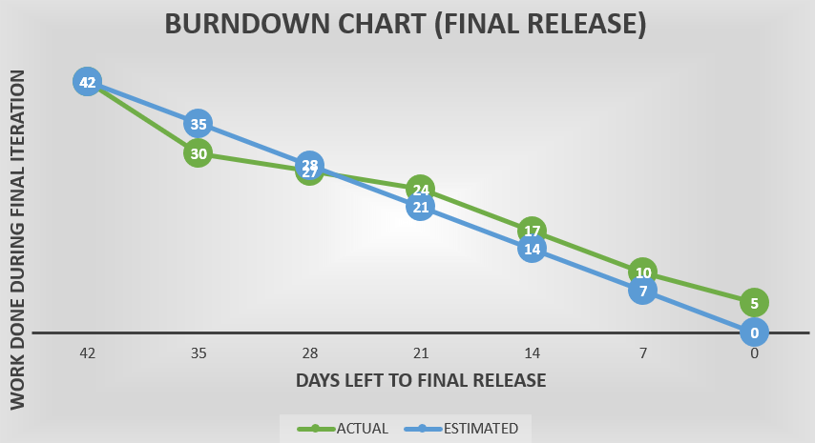

**FINAL VELOCITY CHART**

The Velocity Chart was a means by which the teams’ velocity or pace during the Final Release was measured in order to track progress.

Final Release took six weeks for completion and is represented on the X-Axis. The achievement of work is shown on the Y-Axis.

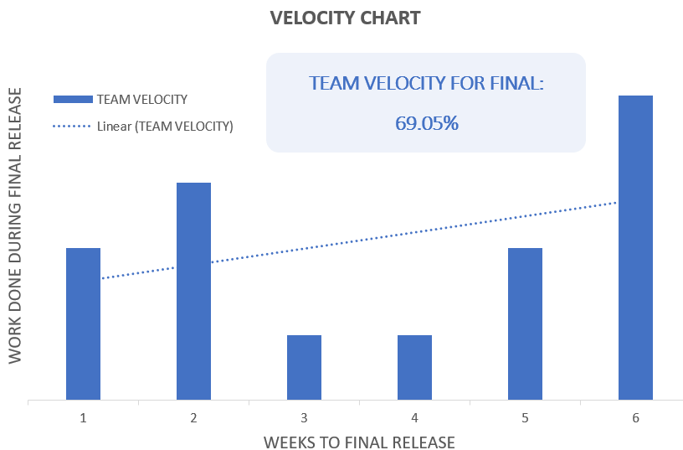

The pace of the team is found to be inconsistent during this iteration. Although, in the last week, the pace is seen to increase in order to meet the client testing deadline.

In the Final iteration, there were 10 User Stories, to be Completed over a total time span of 42 days. But, only tasks that were to be completed within 29 days could be delivered promptly.

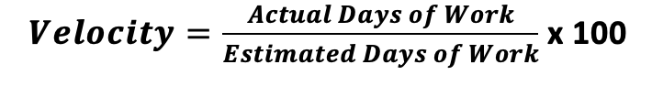The Formula for calculating the velocity of the team is:

Therefore the velocity of this team is (29/42)*100 = **69.05%**

**The Average Team Velocity over all iterations(ALPHA, BETA AND FINAL) is found to be 72.38%**

# CLIENT TESTING

The entire project has been fully tested by the client according to provided test cases bellow. All tested were positive, no problems have been found.

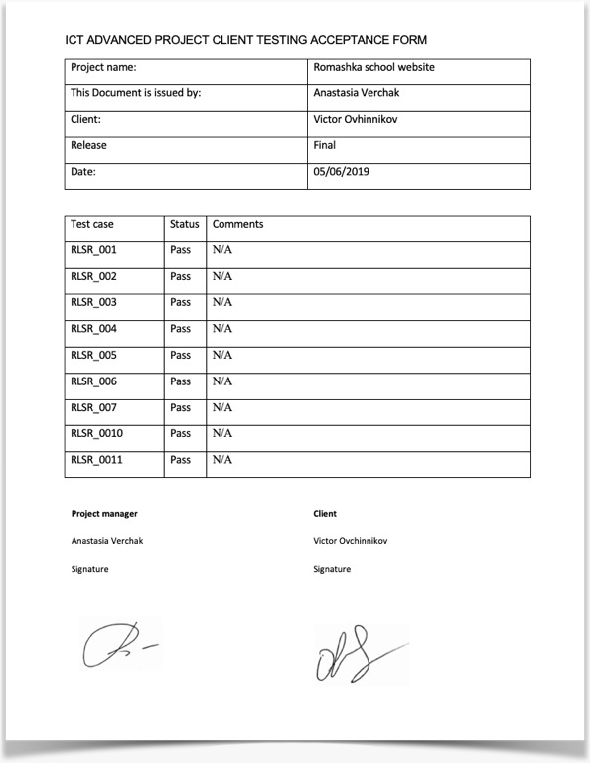

|  |  |
| --- | --- |
| Project Name: Russian Language School Romashka | |
| Test Case | |
| Test Case ID: RLSR_001 | Test Designed by: Anastasia Verchak |
| Test Priority (Low/Medium/High): High | Test Designed date: 07/12/2018 |
| **Module Name:** School login screen | Test Executed by: Victor Ovchinnikov |
| **Test Title:** Test the Login Functionality in the School | Test Execution date: 04/06/2019 |
| **Description:** Verify login with valid username and password |  |

|  |
| --- |
| **Pre-conditions:** User has valid username and password  Dependencies: |

|  |  |  |  |  |  |  |
| --- | --- | --- | --- | --- | --- | --- |
| **N** | **Test Steps** | **Test Data** | **Expected Result** | **Actual Result** | **Status (Pass/Fail)** | **Notes** |
| 1 | Open the web site | <http://romashka.ictatjcub.com/index.php> | Website was open | Website was open | Pass |  |
| 2 | Click to the button Login |  | Login page was open | Login page was open | Pass |  |
| 3 | Provide valid credentials | Login: Admin  Password: 123zxC456! | Credential can be entered | Credential can be entered | Pass |  |
| 4 | Click on Login button |  | User logged | User logged | Pass |  |

|  |  |
| --- | --- |
| Project Name: Russian Language School Romashka | |
| Test Case | |
| Test Case ID: RLSR_002 | Test Designed by: Anastasia Verchak |
| Test Priority (Low/Medium/High): High | Test Designed date: 07/12/2018 |
| **Module Name:** Why us: About us | Test Executed by: Victor Ovchinnikov |
| **Test Title:** Test the functionality of Why us: About us page | Test Execution date: 04/06/2019 |
| **Description:** Verify login with valid username and password |  |

|  |
| --- |
| **Pre-conditions:** Browsers: Safari, Google Chrome  Dependencies: |

|  |  |  |  |  |  |  |
| --- | --- | --- | --- | --- | --- | --- |
| **N** | **Test Steps** | **Test Data** | **Expected Result** | **Actual Result** | **Status (Pass/Fail)** | **Notes** |
| 1 | Open the web site | <http://romashka.ictatjcub.com/index.php> | Website was open | Website was open | Pass |  |
| 2 | Click to the button Why us: About Us |  | About Us was open, there are no types, alignment is correct | About Us was open, there are no types, alignment is correct | Pass |  |
| 3 | Change a screen resolution |  | Size is appropriate | Size is appropriate | Pass |  |

|  |  |
| --- | --- |
| Project Name: Russian Language School Romashka | |
| Test Case | |
| Test Case ID: RLSR_003 | Test Designed by: Anastasia Verchak |
| Test Priority (Low/Medium/High): High | Test Designed date: 07/12/2018 |
| **Module Name:** Why us: Our team | Test Executed by: Victor Ovchinnikov |
| **Test Title:** Test the functionality of Why us: Our team page | Test Execution date: 04/06/2019 |
| **Description:** Why us: Our team page is open and correct |  |

|  |
| --- |
| **Pre-conditions:** Browsers: Safari, Google Chrome  Dependencies: |

|  |  |  |  |  |  |  |
| --- | --- | --- | --- | --- | --- | --- |
| **N** | **Test Steps** | **Test Data** | **Expected Result** | **Actual Result** | **Status (Pass/Fail)** | **Notes** |
| 1 | Open the web site | <http://romashka.ictatjcub.com/index.php> | Website was open | Website was open | Pass |  |
| 2 | Click to the button Why us: Our team |  | Our Team was open, there are no types, alignment is correct | Our Team was open, there are no types, alignment is correct | Pass |  |
| 3 | Change a screen resolution |  | Size is appropriate | Size is appropriate | Pass |  |

|  |  |
| --- | --- |
| Project Name: Russian Language School Romashka | |
| Test Case | |
| Test Case ID: RLSR_003 | Test Designed by: Anastasia Verchak |
| Test Priority (Low/Medium/High): High | Test Designed date: 07/12/2018 |
| **Module Name:** Why us: Our team | Test Executed by: Victor Ovchinnikov |
| **Test Title:** Test the functionality of Why us: Our team page | Test Execution date: 04/06/2019 |
| **Description:** Why us: Our team page is open and correct |  |

|  |
| --- |
| **Pre-conditions:** Browsers: Safari, Google Chrome  Dependencies: |

|  |  |  |  |  |  |  |
| --- | --- | --- | --- | --- | --- | --- |
| **N** | **Test Steps** | **Test Data** | **Expected Result** | **Actual Result** | **Status (Pass/Fail)** | **Notes** |
| 1 | Open the web site | <http://romashka.ictatjcub.com/index.php> | Website was open | Website was open | Pass |  |
| 2 | Click to the button Why us: Our team |  | Our Team was open, there are no types, alignment is correct | Our Team was open, there are no types, alignment is correct | Pass |  |
| 3 | Change a screen resolution |  | Size is appropriate | Size is appropriate | Pass |  |

|  |  |
| --- | --- |
| Project Name: Russian Language School Romashka | |
| Test Case | |
| Test Case ID: RLSR_004 | Test Designed by: Anastasia Verchak |
| Test Priority (Low/Medium/High): High | Test Designed date: 07/12/2018 |
| **Module Name:** Why us: Courses | Test Executed by: Victor Ovchinnikov |
| **Test Title:** Test the functionality of Why us: Courses | Test Execution date: 04/06/2019 |
| **Description:** Why us: Courses page is open and correct |  |

|  |
| --- |
| **Pre-conditions:** Browsers: Safari, Google Chrome  Dependencies: |

|  |  |  |  |  |  |  |
| --- | --- | --- | --- | --- | --- | --- |
| **N** | **Test Steps** | **Test Data** | **Expected Result** | **Actual Result** | **Status (Pass/Fail)** | **Notes** |
| 1 | Open the web site | <http://romashka.ictatjcub.com/index.php> | Website was open | Website was open | Pass |  |
| 2 | Click to the button Why us: Courses |  | Courses was open, there are no types, alignment is correct | Courses was open, there are no types, alignment is correct | Pass |  |
| 3 | Change a screen resolution |  | Size is appropriate | Size is appropriate | Pass |  |
| 4 | Click to the button Pay now for Russian Math |  | Your cart was open | Your cart was open | Pass |  |
| 5 | Click to the button Continue Shopping |  | Courses was open, there are no types, alignment is correct | Courses was open, there are no types, alignment is correct | Pass |  |
| 6 | Click to the button Shopping cart |  | Your cart menu was appear on the right part of the screen and Russian Math is there | Your cart menu was appear on the right part of the screen and Russian Math is there | Pass |  |
| 7 | Click to the button Pay now for Russian Science |  | Your cart was open. Two subjects (Russian Math and Russian Science) are inside and Order summary is $30 | Cart was open. Two subjects (Russian Math and Russian Science) are inside and Order summary is $30 | Pass |  |
| 8 | Click to the button Proceed to checkout |  | Your details are open | Your details are open | Pass |  |
| 9 | Fill the form |  | Form was filled | Form was filled | Pass |  |
| 10 | Click to the button Submit your order |  | Payment was successful, confirmation email was received | Payment was successful, confirmation email was received | Pass |  |

|  |  |
| --- | --- |
| Project Name: Russian Language School Romashka | |
| Test Case | |
| Test Case ID: RLSR_005 | Test Designed by: Anastasia Verchak |
| Test Priority (Low/Medium/High): High | Test Designed date: 07/12/2018 |
| **Module Name:** Events | Test Executed by: Victor Ovchinnikov |
| **Test Title:** Test the functionality of Event page | Test Execution date: 04/06/2019 |
| **Description:** Event page is open and correct |  |

|  |
| --- |
| **Pre-conditions:** Browsers: Safari, Google Chrome  Dependencies: |

|  |  |  |  |  |  |  |
| --- | --- | --- | --- | --- | --- | --- |
| **N** | **Test Steps** | **Test Data** | **Expected Result** | **Actual Result** | **Status (Pass/Fail)** | **Notes** |
| 1 | Open the web site | <http://romashka.ictatjcub.com/index.php> | Website was open | Website was open | Pass |  |
| 2 | Click to the button Event |  | Event was open, there are no types, alignment is correct | Event was open, there are no types, alignment is correct | Pass |  |
| 3 | Change a screen resolution |  | Size is appropriate | Size is appropriate | Pass |  |
| 4 | Click to the button Buy Ticket |  | EventBrite website was open | EventBrite website was open | Pass |  |

|  |  |
| --- | --- |
| Project Name: Russian Language School Romashka | |
| Test Case | |
| Test Case ID: RLSR_006 | Test Designed by: Anastasia Verchak |
| Test Priority (Low/Medium/High): High | Test Designed date: 07/12/2018 |
| **Module Name:** Events | Test Executed by: Victor Ovchinnikov |
| **Test Title:** Test the functionality of News page | Test Execution date: 04/06/2019 |
| **Description:** News page is open and correct |  |

|  |
| --- |
| **Pre-conditions:** Browsers: Safari, Google Chrome  Dependencies: |

|  |  |  |  |  |  |  |
| --- | --- | --- | --- | --- | --- | --- |
| **N** | **Test Steps** | **Test Data** | **Expected Result** | **Actual Result** | **Status (Pass/Fail)** | **Notes** |
| 1 | Open the web site | <http://romashka.ictatjcub.com/index.php> | Website was open | Website was open | Pass |  |
| 2 | Click to the button News |  | News was open, there are no types, alignment is correct | News was open, there are no types, alignment is correct | Pass |  |
| 3 | Change a screen resolution |  | Size is appropriate | Size is appropriate | Pass |  |
| 4 | Click to the button Read more |  | News detail was open, alignment is correct | News detail was open, alignment is correct | Pass |  |

|  |  |
| --- | --- |
| Project Name: Russian Language School Romashka | |
| Test Case | |
| Test Case ID: RLSR_007 | Test Designed by: Anastasia Verchak |
| Test Priority (Low/Medium/High): High | Test Designed date: 07/12/2018 |
| **Module Name:** Contact us | Test Executed by: Victor Ovchinnikov |
| **Test Title:** Test the functionality of Contact Us page | Test Execution date: 04/06/2019 |
| **Description:** Contact us page is open and correct |  |

|  |
| --- |
| **Pre-conditions:** Browsers: Safari, Google Chrome  Dependencies: |

|  |  |  |  |  |  |  |
| --- | --- | --- | --- | --- | --- | --- |
| **N** | **Test Steps** | **Test Data** | **Expected Result** | **Actual Result** | **Status (Pass/Fail)** | **Notes** |
| 1 | Open the web site | <http://romashka.ictatjcub.com/index.php> | Website was open | Website was open | Pass |  |
| 2 | Click to the button Contact us |  | Contact us was open, there are no types, alignment is correct | Contact us was open, there are no types, alignment is correct | Pass |  |
| 3 | Change a screen resolution |  | Size is appropriate | Size is appropriate | Pass |  |
| 4 | Check the address |  | Address is 6 Lawson St, Southport | Address is 6 Lawson St, Southport | Pass |  |
| 5 | Fill the form |  | Form was filled | Form was filled | Pass |  |
| 6 | Click on the button Send Message |  | Message was sent | Message was sent | Pass |  |

|  |  |
| --- | --- |
| Project Name: Russian Language School Romashka | |
| Test Case | |
| Test Case ID: RLSR_008 | Test Designed by: Anastasia Verchak |
| Test Priority (Low/Medium/High): High | Test Designed date: 07/12/2018 |
| **Module Name:** User Registration | Test Executed by: Victor Ovchinnikov |
| **Test Title:** Test the functionality of User Registration page | Test Execution date: 04/06/2019 |
| **Description:** User Registration page is open and correct |  |

|  |
| --- |
| **Pre-conditions:** Browsers: Safari, Google Chrome  Dependencies: |

|  |  |  |  |  |  |  |
| --- | --- | --- | --- | --- | --- | --- |
| **N** | **Test Steps** | **Test Data** | **Expected Result** | **Actual Result** | **Status (Pass/Fail)** | **Notes** |
| 1 | Open the web site | <http://romashka.ictatjcub.com/index.php> | Website was open | Website was open | Pass |  |
| 2 | Click to the button Sign Up |  | Sign Up was open, there are no types, alignment is correct | Sign Up was open, there are no types, alignment is correct | Pass |  |
| 3 | Change a screen resolution |  | Size is appropriate | Size is appropriate | Pass |  |
| 4 | Fill the form |  | Form was filled | Form was filled | Pass |  |
| 6 | Click on the button Sign Up |  | User was successfully registered | User was successfully registered | Pass |  |

|  |  |
| --- | --- |
| Project Name: Russian Language School Romashka | |
| Test Case | |
| Test Case ID: RLSR_008 | Test Designed by: Anastasia Verchak |
| Test Priority (Low/Medium/High): High | Test Designed date: 07/12/2018 |
| **Module Name:** User Registration | Test Executed by: Victor Ovchinnikov |
| **Test Title:** Test the functionality of User Registration page | Test Execution date: 04/06/2019 |
| **Description:** User Registration page is open and correct |  |

|  |
| --- |
| **Pre-conditions:** Browsers: Safari, Google Chrome  Dependencies: |

|  |  |  |  |  |  |  |
| --- | --- | --- | --- | --- | --- | --- |
| **N** | **Test Steps** | **Test Data** | **Expected Result** | **Actual Result** | **Status (Pass/Fail)** | **Notes** |
| 1 | Open the web site | <http://romashka.ictatjcub.com/index.php> | Website was open | Website was open | Pass |  |
| 2 | Click to the button Sign Up |  | Sign Up was open, there are no types, alignment is correct | Sign Up was open, there are no types, alignment is correct | Pass |  |
| 3 | Change a screen resolution |  | Size is appropriate | Size is appropriate | Pass |  |
| 4 | Fill the form |  | Form was filled | Form was filled | Pass |  |
| 6 | Click on the button Sign Up |  | User was successfully registered | User was successfully registered | Pass |  |

|  |  |
| --- | --- |
| Project Name: Russian Language School Romashka | |
| Test Case | |
| Test Case ID: RLSR_009 | Test Designed by: Anastasia Verchak |
| Test Priority (Low/Medium/High): High | Test Designed date: 07/12/2018 |
| **Module Name:** New user in Moodle | Test Executed by: Victor Ovchinnikov |
| **Test Title:** Create new Users in Moodle | Test Execution date: 04/06/2019 |
| **Description:** New userin Moodle |  |

|  |
| --- |
| **Pre-conditions:** Browsers: Safari, Google Chrome  Dependencies: |

|  |  |  |  |  |  |  |
| --- | --- | --- | --- | --- | --- | --- |
| **N** | **Test Steps** | **Test Data** | **Expected Result** | **Actual Result** | **Status (Pass/Fail)** | **Notes** |
| 1 | Open the web site | <http://romashka.ictatjcub.com/index.php> | Website was open | Website was open | Pass |  |
| 2 | Click to the button Login | Login: Admin  Password: 123zxC456! | Moodle login page opened | Sign Up was open, there are no types, alignment is correct | Pass |  |
| 3 | In the Site Administration section on the left in the Settings section, navigate to Users > Accounts, click Add new users. |  | Add new user window was open | Add new user window was open | Pass |  |
| 4 | On the Add new user page, Fill out the required fields. The required fields show in red and are the Username, New password, First name, Surname, Email address, City/town, and Select a country. Below is a brief description of what each section contains. Once these values are set |  | Form was filled | Form was filled | Pass |  |
| 6 | Click Update Profile |  | User was created | User was created | Pass |  |

|  |  |
| --- | --- |
| Project Name: Russian Language School Romashka | |
| Test Case | |
| Test Case ID: RLSR_010 | Test Designed by: Anastasia Verchak |
| Test Priority (Low/Medium/High): High | Test Designed date: 07/12/2018 |
| **Module Name:** Courses | Test Executed by: Victor Ovchinnikov |
| **Test Title:** Enrolling users in Moodle Courses | Test Execution date: 04/06/2019 |
| **Description:** Enrolling users in Moodle Courses |  |

|  |
| --- |
| **Pre-conditions:** Browsers: Safari, Google Chrome  Dependencies: |

|  |  |  |  |  |  |  |
| --- | --- | --- | --- | --- | --- | --- |
| **N** | **Test Steps** | **Test Data** | **Expected Result** | **Actual Result** | **Status (Pass/Fail)** | **Notes** |
| 1 | Open the web site | <http://romashka.ictatjcub.com/index.php> | Website was open | Website was open | Pass |  |
| 2 | Click to the button Login | Login: Admin  Password: 123zxC456! | Moodle login page opened | Sign Up was open, there are no types, alignment is correct | Pass |  |
| 3 | Click the Course you are adding the user to. In the Settings section, go to Users > Enrolled users. |  | Enrolled users window was opened | Enrolled users window was opened | Pass |  |
| 4 | On the Enrolled users page, click the Enrol users button. |  | Enrol user box was shown | Enrol user box was shown | Pass |  |
| 5 | Click the Enrol button next to the name of the user to add the user. When a user is added, the user will indent in and the Enrol button will disappear. |  | Enrol button disappeared | Enrol button disappeared | Pass |  |
| 6 | When done click Finish enrolling users |  | User was enrolled | User was enrolled | Pass |  |

|  |  |
| --- | --- |
| Project Name: Russian Language School Romashka | |
| Test Case | |
| Test Case ID: RLSR_011 | Test Designed by: Anastasia Verchak |
| Test Priority (Low/Medium/High): High | Test Designed date: 07/12/2018 |
| **Module Name:** Courses | Test Executed by: Victor Ovchinnikov |
| **Test Title:** New course | Test Execution date: 04/06/2019 |
| **Description:** Creating Courses in Moodle |  |

|  |
| --- |
| **Pre-conditions:** Browsers: Safari, Google Chrome  Dependencies: |

|  |  |  |  |  |  |  |
| --- | --- | --- | --- | --- | --- | --- |
| **N** | **Test Steps** | **Test Data** | **Expected Result** | **Actual Result** | **Status (Pass/Fail)** | **Notes** |
| 1 | Open the web site | <http://romashka.ictatjcub.com/index.php> | Website was open | Website was open | Pass |  |
| 2 | Click to the button Login | Login: Admin  Password: 123zxC456! | Moodle login page opened | Sign Up was open, there are no types, alignment is correct | Pass |  |
| 3 | Go to the settings section |  | Setting window was opened | Setting window was opened | Pass |  |
| 4 | Click on the button Add a new course |  | New course window was opened | New course window was opened | Pass |  |
| 5 | Fill the form. Click the button Save |  | New course was created | New course was created | Pass |  |

# CLIENT USER MANUAL

All functionality of the System could be found in the User Manual, which answer for all basic questions about the System. Full version is available at .pdf format and was given to the Client before the client testing.

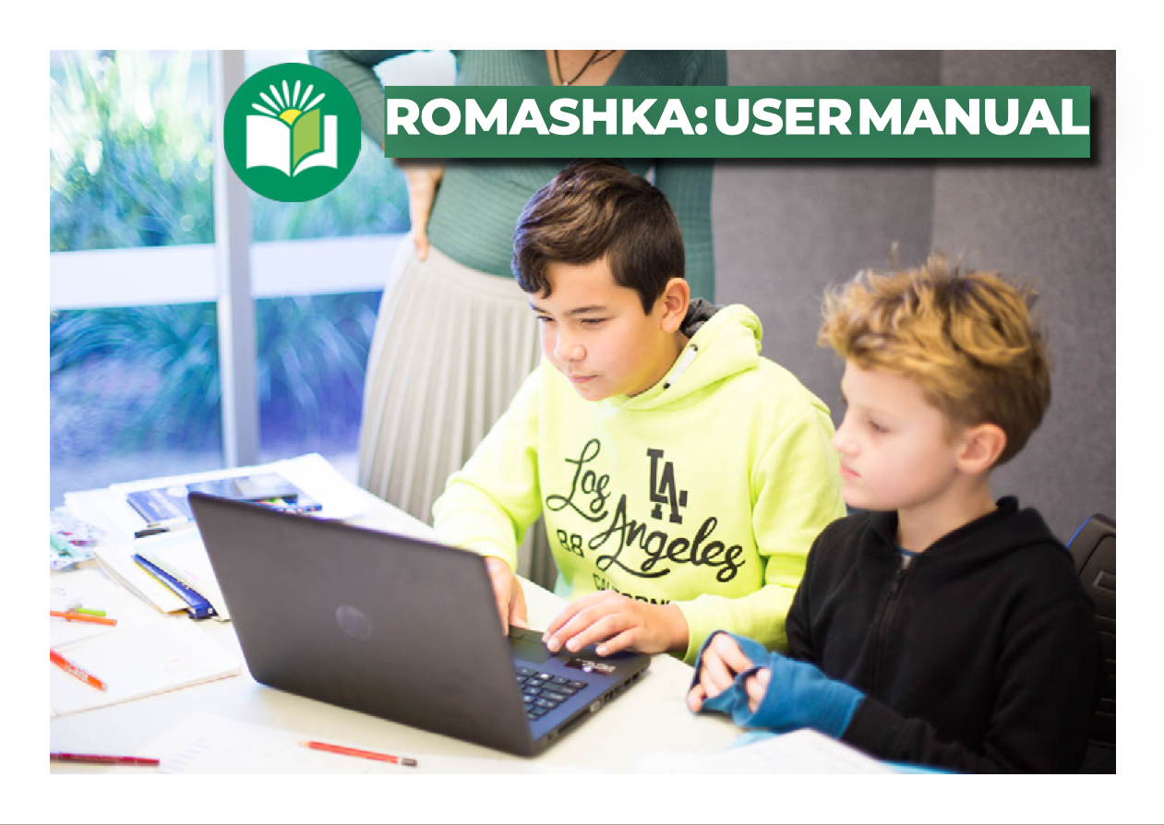

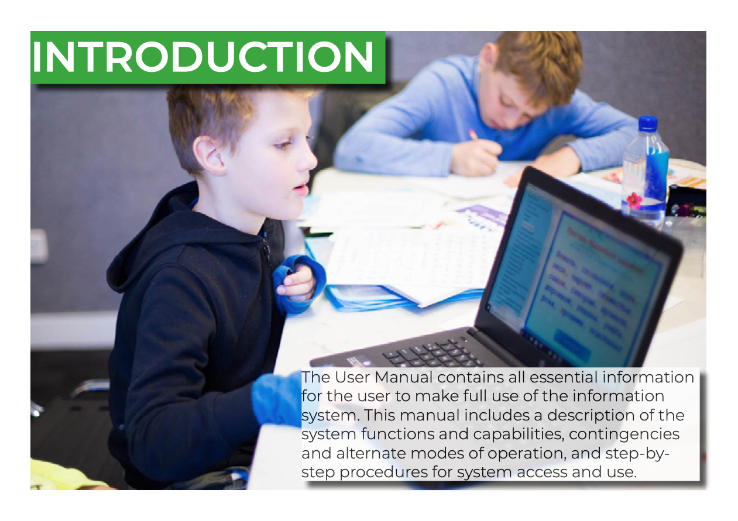

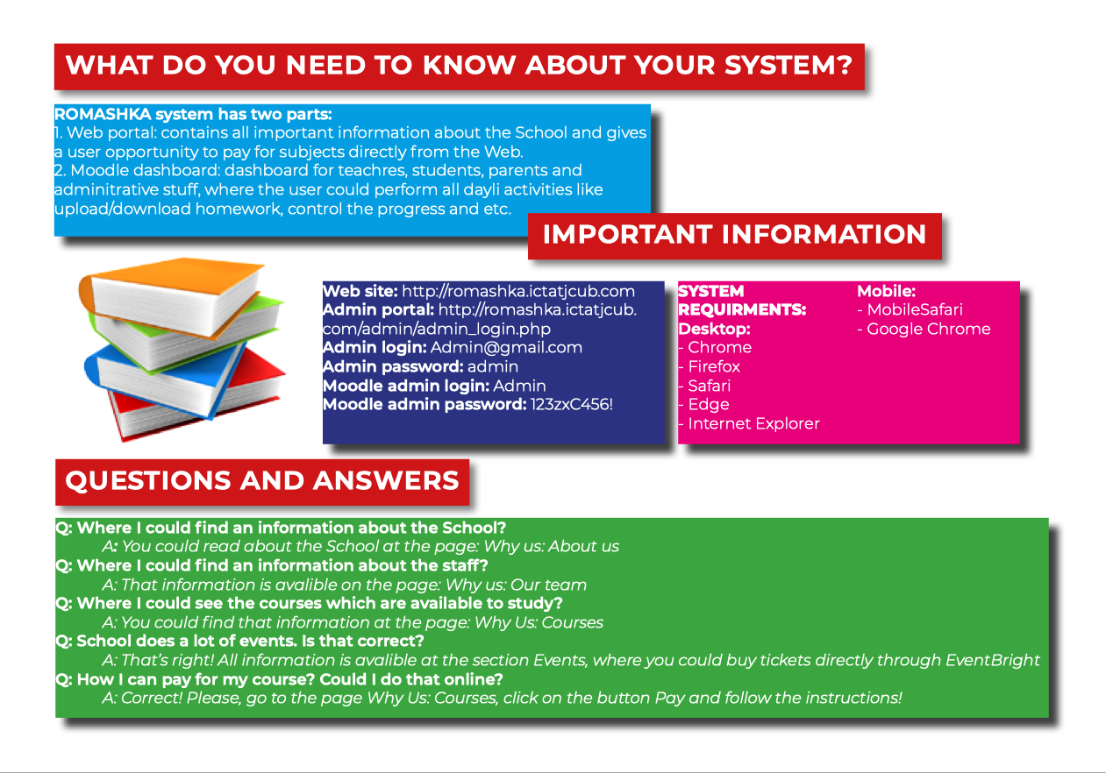

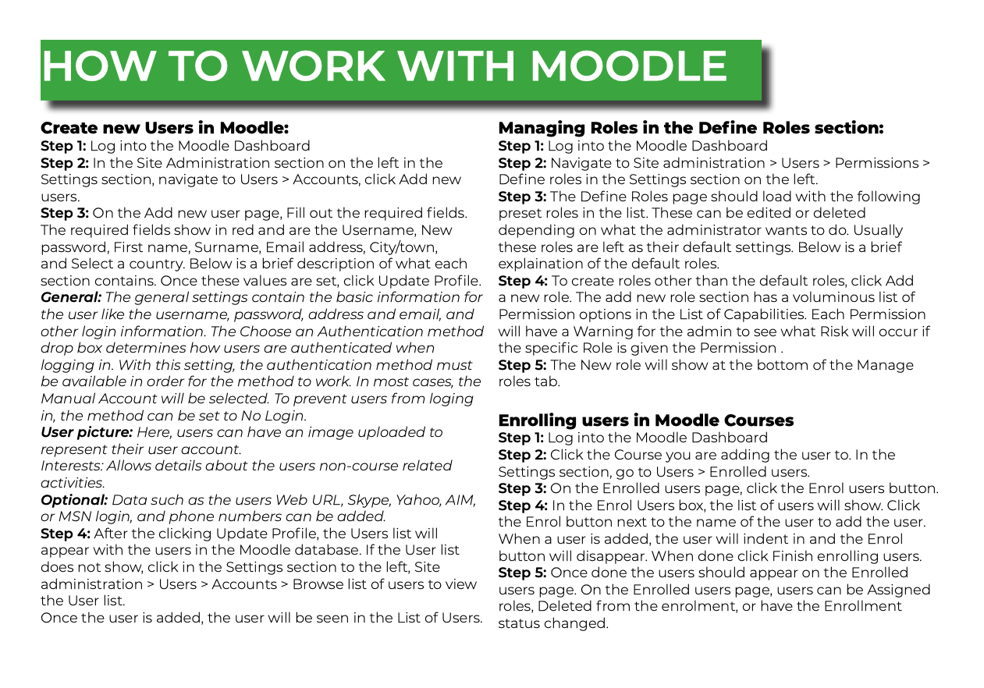

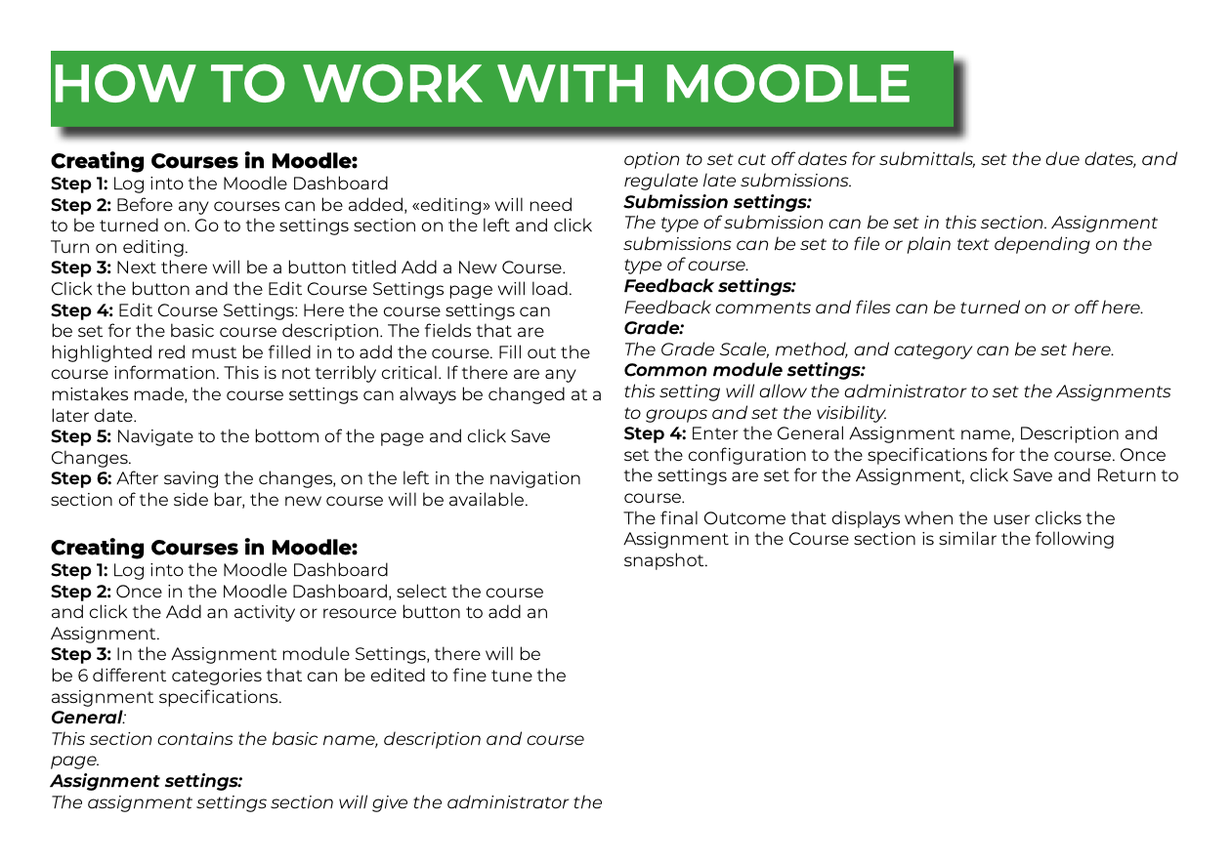

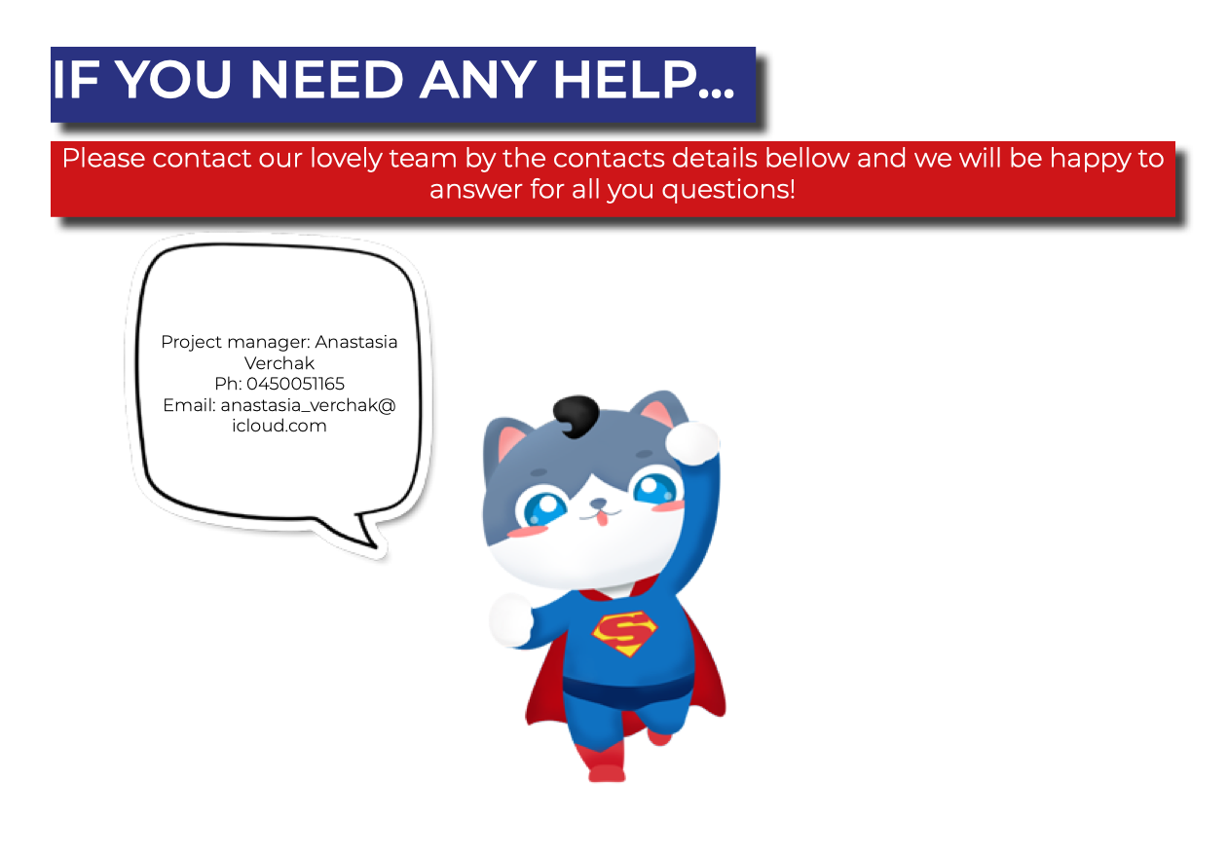

# CONCLUSION

The project ‘Romashka’ now stands completed, with most of the client requirements delivered along with some additional features. The client acceptance forms for all the three iterations, Alpha, Beta and Final are clearly evidenced in this documentation.

The project has been successfully tested by the client and relevant feedback has been obtained and documented.

The major differences between all the iterations as the project progressed, have been clearly highlighted in this document.

The progress of the team has been constantly monitored throughout the project, over all three iterations and depicted in the form of Burndown and Velocity Charts.

This project has been a great learning experience for the developers in the team as well as the Project Manager.